**AI Book Summarizer**

This documentation was submitted as required for the degree of bachelor’s in Computer and Information Sciences.

By

Ahmad Hany Ahmad Abdulmageed [Scientific Computing Department]

Ahmed Wail Salah Eldeen Hassan [Scientific Computing Department]

Abdelrahman Mohamed Azazy Mohamed [Scientific Computing Department]

Esraa Saad Abd Elhameed Said [Scientific Computing Department]

Ganna Ayman Talaat Mostafa [Scientific Computing Department]

George Saeid Selim Saweres [Scientific Computing Department]

Under supervision of

Dr. Maryam Al-Berry

Assistant Professor of Scientific Computing Department

Faculty of Computer and Information Sciences,

Ain Shams University.

TA. Hazem Youssef

Teaching Assistant of Scientific Computing Department,

Faculty of Computer and Information Sciences,

Ain Shams University.

June 2024

**Acknowledgments**

We would like to express our sincere gratitude to all those who have supported us throughout the completion of this project.

First and foremost, we would like to thank Allah for giving us the strength and perseverance to see this project through to the end.

We would like to thank our doctor, Dr. Maryam Al-Berry, for her meticulous supervision, insightful comments, and helpful suggestions throughout the project. Her expertise and dedication to our success were instrumental in helping us achieve our goals.

We are also deeply grateful to our TA. Hazem Youssef for her unwavering guidance, support, and encouragement throughout the project. Her insights and feedback were invaluable in helping us refine our ideas and improve the project's quality.

We would also like to thank our team members for their hard work, cooperation, and commitment to excellence. Their contributions were essential in bringing this project to fruition.

Finally, we would like to thank our families for their unwavering love, support, and encouragement throughout our academic journey. Their sacrifices and dedication have been the foundation of our success. Thank you all for your contributions to this project and for making this experience a memorable one.

**Abstract**

The Book Summarize Application is an innovative and indispensable tool designed to cater to a diverse audience, including avid readers, students, researchers, and busy professionals who seek to optimize their reading efficiency and comprehension. This cutting-edge application leverages advanced natural language processing algorithms and artificial intelligence to analyze and distill the core ideas, themes, and key points from extensive texts, providing users with concise, accurate, and insightful summaries. By doing so, it enables users to grasp the essential content and critical insights of original works without the need to wade through lengthy volumes.

Users can input books from a wide array of genres and fields, ranging from fiction and non-fiction to academic and technical literature, and receive tailored summaries that retain the essence and nuances of the source material. The application offers customizable summary lengths to suit individual preferences and requirements, allowing users to choose between brief overviews and more detailed condensations. Additionally, it supports multiple languages, making it a versatile tool for a global audience.

Seamless integration with e-readers, digital libraries, and other online platforms ensures that users can easily access and manage their summaries on the go. The Book Summarize Application also features an intuitive and user-friendly interface, complete with options for highlighting, annotating, and saving important sections for future reference. By enhancing the reading experience and making literature more accessible and manageable, this application empowers users to stay informed, educated, and enlightened amidst the overwhelming influx of information in today's digital age.

In summary, the Book Summarize Application stands out as a revolutionary solution that not only saves time but also enriches the intellectual pursuits of its users. It is an essential companion for anyone looking to stay ahead in their personal, academic, or professional lives by effectively managing and absorbing knowledge from a vast array of sources.

**Table of Contents**

**Acknowledgments**..........................................................................2

**Abstract**...........................................................................................3

**List of Figures**.................................................................................5

**List of Tables**..................................................................................6

**List of Abbreviation**.......................................................................7

**Chapter 1:** **Introduction**................................................................8

1.1 Problem Definition.........................................................9

1.2 Motivation......................................................................10

1.3 Objectives.......................................................................11

1.4 Time plan........................................................................12

1.5 Document Organization..................................................13

**Chapter 2:** **Literature Review** .....................................................15

2.1 Introduction....................................................................16

2.2 TechnicalBackground ...................................................17

2.3 Related Work .................................................................18

2.4 Conclusion .....................................................................41

**Chapter 3:** **System Architecture and Methods** ..........................44

3.1 System Architecture .......................................................44

3.3 Components ...................................................................45

3.2 Description of methods and procedures used ................46

**Chapter 4:** **System Implementation and Results** .......................53

4.1 Dataset ............................................................................54

4.2 Software Tools Used ......................................................60

4.3 Setup configuration ........................................................64

4.4 Experimental and Results ...............................................66

**Chapter 5:** User Interface System..................................................71

5.1 Introduction....................................................................71

5.2 Overview of the UI System ............................................71

5.3 Frontend Design .............................................................71

5.4 Backend Design ..............................................................73

**Chapter 6:** Conclusion and Future Work.......................................77

6.1 Conclusion......................................................................77

6.2 Future Work....................................................................78

**References**......................................................................................81

**List of Figures**

**Fig 1.1** Time Plan.............................................................................................12

**Fig 2.1** Flow of the model.................................................................................31

**Fig 2.2** Relation between likert and model size................................................36

**Fig 2.3** Relation likert and total dims................................................................37

**Fig 3.1** System Architecture .............................................................................44

**Fig 3.2 Tree of Summarization………………………………………………..46**

**Fig 3.3** Example about T5.................................................................................49

**Fig 4.1** number of books in dataset...................................................................55

**List of Tables**

**Table 2.1** Rouge Scores for book abstraction...................................31

**Table 2.2** Results of Rouge accuracies.............................................38

**Table 2.3** of accuracies RL vs BC....................................................39

**Table 4.1** Statistics of the BOOKSUM data collection....................56

**Table 4.2** Performance of baseline models.......................................57

**Table 5.1** Bart zero-shot results using ROUGE matrix ...................67

**Table 5.2** T5 zero-shot results using ROUGE matrix ......................67

**Table 5.3** Bart fine-tuned results using ROUGE matrix ..................68

**Table 5.4** T5 fine-tuned results using ROUGE matrix .....................68

**List of Abbreviations**

• **AI** - Artificial Intelligence

• **NLP** - Natural Language Processing

• **ML** - Machine Learning

• **GPU** - Graphics Processing Unit

• **IDE** - Integrated Development Environment

• **RESTful API** - Representational State Transfer Application Programming Interface

• **T5** - Text-to-Text Transfer Transformer

• **BART** - Bidirectional and Auto-Regressive Transformers

• **PEGASUS** - Pre-training with Extracted Gap-sentences for Abstractive Summarization Sequence-to-sequence model

• **HTML** - HyperText Markup Language

• **VS Code** - Visual Studio Code

• **Flask** - A lightweight WSGI web application framework in Python

• **PyTorch** - An open-source machine learning library

• **NLTK** - Natural Language Toolkit

• **NER** - Named Entity Recognition

• **POS** - Part-of-Speech Tagging

• **ROUGE** - Recall-Oriented Understudy for Gisting Evaluation

• **BLEU** - Bilingual Evaluation Understudy

• **PDF** - Portable Document Format

Chapter 1

_________________________

Introduction

__________________________

**Chapter 1 - Introduction**

The explosion of digital content in the form of books, articles, and other textual materials has made information more accessible than ever before. However, the sheer volume of available text has also created a significant challenge: information overload. Readers often struggle to extract relevant information from large texts quickly and efficiently. This problem is particularly pronounced for lengthy documents such as books, where manually summarizing content is time-consuming and impractical. Consequently, there is a pressing need for automated solutions that can generate concise and coherent summaries of books, facilitating faster information retrieval and comprehension.

**1.1 Problem Definition:**

Reading entire books and novels can present a multitude of challenges, making the endeavor daunting for many modern readers. One of the most significant issues is the substantial time commitment required to read a full-length book, which can be particularly problematic for individuals juggling busy schedules filled with work, family responsibilities, and social obligations. In an era where time is a precious commodity, dedicating hours or even days to reading a single book can seem impractical and overwhelming.

Moreover, the sheer volume of literature available today can be intimidating. With countless books published annually across various genres, readers often struggle to decide which books deserve their attention. This abundance can lead to decision paralysis, where the fear of missing out on one book prevents the enjoyment of another. For students and professionals, the challenge is further compounded by the need to read and comprehend dense, information-rich texts that may require prior knowledge or context to fully understand. This can be particularly true for academic or technical literature, where complex concepts and specialized terminology can hinder comprehension and retention.

In addition to these time and content-related challenges, the modern digital age brings its own set of distractions. The constant influx of notifications from electronic devices, social media, and other digital platforms can severely disrupt reading habits, making it difficult to maintain focus and concentration. This fragmented attention span not only reduces the pleasure of reading but also impairs the ability to fully immerse oneself in a narrative or grasp the nuanced arguments in non-fiction works.

Furthermore, the fast-paced nature of contemporary life often leads to a preference for shorter, more immediately gratifying content, such as articles, blog posts, and videos, over longer, more demanding books and novels. This shift in reading habits can result in a decline in deep reading and critical thinking skills, as well as a diminished appreciation for the rich, layered storytelling that only longer works can provide.

These factors collectively contribute to a decline in reading engagement and comprehension, making it increasingly difficult for readers to fully immerse themselves in and appreciate the richness of entire books and novels. Overcoming these obstacles requires a concerted effort to prioritize reading, manage distractions, and cultivate a deeper appreciation for the literary arts amidst the myriad demands of modern life.

As a result of these above problems the percentage of readers has decreased over the years.

**1.2 Motivation:**

In today's fast-paced world, the ability to quickly assimilate and comprehend large volumes of information is more crucial than ever. Whether for academic purposes, professional development, or personal enrichment, readers often face the daunting task of navigating through extensive texts to extract pertinent information. This challenge is particularly pronounced for students, researchers, and professionals who must stay abreast of vast amounts of literature within limited timeframes.

This project was conceived to address this need by leveraging the power of artificial intelligence to distill the essence of lengthy texts into concise, coherent summaries. The motivation behind this project is threefold:

1. **Enhancing Learning Efficiency:**

By providing succinct summaries, this project empowers users to quickly grasp key concepts and arguments presented in books, thereby facilitating more efficient learning and study processes. This is particularly beneficial for students who need to review large volumes of academic material in a short period.

1. **Increasing Accessibility:**

Many readers are deterred by the sheer length and complexity of certain texts. This project aims to democratize access to knowledge by making it easier for a broader audience to engage with and understand complex material. This increased accessibility can help bridge knowledge gaps and foster a more informed society.

1. **Supporting Decision-Making:**

In the professional realm, quick access to relevant information can significantly impact decision-making processes. This project assists professionals by providing them with the critical insights they need without the time-consuming task of reading entire books. This tool can be invaluable for executives, researchers, and policy-makers who must make informed decisions swiftly.

**1.3 Objective:**

The primary objective of this project is to develop an advanced, user-friendly platform that leverages state-of-the-art natural language processing (NLP) techniques to generate accurate and coherent summaries of PDF books. This platform aims to:

1. **Provide Accurate Summaries:**

Develop a robust summarization model, based on the T5 transformer architecture, capable of producing concise and accurate summaries that effectively capture the key points and overall essence of lengthy texts.

1. **Enhance User Experience:**

Design an intuitive and accessible web interface using React, ensuring that users can easily upload PDF books, generate summaries, and view results in a seamless manner. The interface should be responsive, visually appealing, and straightforward to navigate.

1. **Optimize Performance:**

Implement backend functionalities using Flask to handle PDF processing and summarization tasks efficiently. This includes optimizing model parameters and processing workflows to deliver fast and reliable results to users.

1. **Facilitate Accessibility:**

Ensure the platform is accessible to a wide audience, including students, researchers, and professionals, by supporting various types of PDF content and accommodating diverse user requirements.

1. **Promote Lifelong Learning:**

Foster a culture of continuous learning by providing a tool that helps users quickly assimilate information, enabling them to stay updated with current literature, research, and developments in their fields of interest.

**1.4 Organization plan:**

Before we began this project, we have put to ourselves a time plan that we were moving according to it.

Fig 1.1 Time Plan

**1.5 Document Organization:**

**Chapter 2 (Literature Review):**

In this chapter, we will discuss the most important work related to our project.

**Chapter 3 (System Architecture and Methods)**:

In this chapter, we will present the techniques we have used to implement our system.

**Chapter 4 (System Implementation and Results):**

In this chapter, we will present the experimental results for all system phases separately.

**Chapter 5 (User Interface)**:

In this chapter, we will present the design and the shape of the user interface we have made to be displayed to the user to interact with it.

**Chapter 6 (Conclusion and Future work)**:

In this chapter, we will present our conclusion and what we will do to increase the efficiency of our system and enhance the user interface.

Chapter 2

________________________

Literature Review _________________________

**Chapter 2 - Literature Review**

**2.1 Introduction:**

In today's digital age, the exponential growth of information has created a significant challenge in managing and processing vast amounts of text data. Text summarization, a critical area of research within natural language processing (NLP), addresses this challenge by automatically condensing large text documents into shorter versions while preserving essential information and key points. This ability to distill information is invaluable in numerous applications, including news aggregation, document management, and information retrieval, making text summarization a pivotal tool for enhancing productivity and information accessibility.

The advent of machine learning and deep learning techniques has revolutionized text summarization, enabling more accurate and context-aware summaries. Among these techniques, transformer-based models have shown remarkable success. Introduced in 2017 by Vaswani et al., the transformer architecture has become the foundation for many state-of-the-art NLP models. Its ability to handle long-range dependencies and parallelize training processes has made it particularly effective for tasks involving large and complex text corpora.

The T5 (Text-to-Text Transfer Transformer) model, developed by Google Research, represents a significant advancement in transformer-based NLP models. By framing all NLP tasks as a text-to-text problem, T5 simplifies the approach to training models for various tasks, including text summarization, translation, and question answering. The flexibility and robustness of T5 have established it as a powerful tool for generating high-quality text summaries, making it an ideal candidate for the project.

In this chapter, we will delve into the technical background of text summarization, exploring the fundamental concepts of NLP and machine learning that underpin modern summarization techniques. We will then review related work in the field, highlighting significant research studies and existing models that have contributed to the advancement of text summarization. This literature review aims to provide a comprehensive understanding of the current state of the art, identify existing challenges, and establish a foundation for the novel contributions of this project.

**2.2 Technology Background:**

Text summarization techniques have evolved significantly with advancements in natural language processing (NLP) and machine learning (ML). This section provides an overview of the key methodologies and technologies that form the foundation for modern text summarization systems.

**2.2.1 Natural Language Processing (NLP):**

Natural Language Processing (NLP) is a subfield of artificial intelligence that focuses on enabling computers to understand, interpret, and generate human language. Key tasks in NLP relevant to text summarization include:

* **Tokenization and Text Preprocessing:** Tokenization breaks down text into smaller units (tokens), such as words or subwords, to facilitate further analysis. Preprocessing involves tasks like removing stop words, stemming, and handling special characters to clean and normalize text data.
* **Named Entity Recognition (NER):** NER identifies and classifies named entities (e.g., persons, organizations, locations) within text, which is crucial for understanding the context and importance of entities in a document.
* **Part-of-Speech Tagging (POS):** POS tagging assigns grammatical categories (e.g., noun, verb, adjective) to words in a sentence, aiding in syntactic analysis and meaning extraction.

**2.2.2 Machine Learning Techniques:**

Machine learning techniques play a vital role in text summarization, enabling models to learn from large datasets and generate summaries autonomously. Key ML techniques include:

* **Supervised Learning:** In supervised learning, models are trained on labeled datasets where each input (e.g., document) is associated with a corresponding output (e.g., summary). This approach is commonly used for extractive summarization methods.
* **Unsupervised Learning:** Unsupervised learning techniques, such as clustering and topic modeling, do not rely on labeled data. These methods can identify themes and important sections within text corpora, which can be used to generate summaries.

**2.2.3 Transformer Architectures:**

Transformer architectures, introduced by Vaswani et al. (2017), have revolutionized NLP tasks, including text summarization. Transformers leverage self-attention mechanisms to capture long-range dependencies within sequences, making them well-suited for tasks requiring contextual understanding and sequential data processing.

* **BERT (Bidirectional Encoder Representations from Transformers):** BERT, a transformer-based model, introduced bidirectional training for NLP tasks, significantly improving performance on tasks like question answering and text classification.
* **T5 (Text-to-Text Transfer Transformer):** Developed by Google Research, T5 frames all NLP tasks as text-to-text problems, simplifying the training and deployment of models across different tasks, including text summarization.

**2.2.4 Evaluation Metrics:**

Evaluating the quality of generated summaries is essential for assessing summarization models' effectiveness. Common evaluation metrics include:

* **ROUGE (Recall-Oriented Understudy for Gisting Evaluation):** ROUGE measures overlap between generated summaries and reference summaries based on n-gram overlap and word sequence similarity.
* **BLEU (Bilingual Evaluation Understudy):** Originally designed for machine translation, BLEU measures the similarity between generated summaries and reference summaries based on n-gram precision.

**2.2.4 Summary of Technical Background:**

This section has provided an overview of the fundamental concepts and technologies that underpin modern text summarization techniques. Understanding these concepts is crucial for developing and evaluating effective summarization models, which will be further explored in the subsequent sections.

**2.2 Related Work:**

This literature review examines four key papers on the topic of AI-driven book summarization, highlighting the methodologies, datasets, and performance outcomes. The papers reviewed are:

1. BOOKSUM: A Collection of Datasets for Long-form Narrative Summarization.
2. BART: Denoising Sequence to Sequence Pre-training for Natural Language Generation, Translation, and Comprehension.
3. Transformer-Based Implementation for Automatic Book Summarization.
4. Recursively Summarizing Books with Human Feedback.

#### **1. BOOKSUM: A Collection of Datasets for Long-form Narrative Summarization**

**1 Introduction**

Text summarization aims at condensing long documents into a short, human-readable form which contains only the salient parts of the source. Lever aging the cutting-edge findings in natural language processing, such as multi-task learning methods [5], pre-training strategies [11], and memory-efficient architectures, text summarization has seen substantial progress. The majority of papers published in the field focus on summarizing newswire documents from popular datasets, such as CNN/DailyMail [12]. Other domains gaining interest of the research community are scientific and legal documents, with notable datasets being Arxiv /PubMed [13] and Big Patent [14]. While the performance of state-of-the-art methods on those datasets is impressive, the mentioned domains have inherent shortcomings and thus pose limited challenges for future generations of text summarization systems. First, the length of summarized documents is limited, ranging from a few hundred words in case of news articles, to a few pages for scientific documents and patent applications. In most cases, such short-form documents can be quickly read by humans, thus limiting the practical value of automatic summarization systems. Second, the domains under consideration impose strict requirements regarding the document’s layout and stylistic features1. Statements follow a logical order and all facts are offered explicitly, leaving limited space for interpretation and reasoning. Addition ally, such constraints, can introduce layout biases into the datasets which later dominate the training signal of the summarization systems. The lead bias present in news articles being one example of such effects [15]. Third, documents in the mentioned domains lack long-range causal and temporal dependencies, and rich discourse structures. Due to the limited length and fact-centric style of writing, most causal dependencies span only a few para graphs, temporal dependencies are organized in a monotonic fashion where newly introduced facts refer only to previously stated information, and document lacks features such as parallel plot lines. In this work we address the shortcomings of existing datasets and introduce BOOKSUM, a col lection of data resources for long-form narrative summarization [16]. The data covers documents from the literature domain, including stories, plays, and novels, each provided with a highly abstractive, human-written summary. Leveraging the characteristics of fiction writing, BOOKSUM introduces a set of new challenges for summarization systems: processing long

**Methodology:** The BOOKSUM paper presents a collection of datasets designed specifically for long-form narrative summarization. These datasets include various forms of long narrative texts, such as books and chapters, along with their summaries. The primary focus is on creating a robust dataset that can aid in training and evaluating summarization models.

**Dataset :**

In this section we describe the data sources and pre-processing steps taken to create the BOOK SUM data collection and conduct an in-depth anal ysis of the collected resources.

**3.1 Data Collection**

**Data Sources** :

Despite the popularity of books in electronic format, aggregating and sharing literature pieces is a non-trivial task due to the copyright law protecting such documents. The source documents available in BOOKSUM were collected from the Project Gutenberg public-domain book repos itory2 and include plays, short stories, and novels of which copyrights have expired. Associated sum maries were collected using content provided by the Web Archive3. The summary data includes both book- and chapter-level summaries.

**Data Acquisition**:

Source texts were downloaded in plain text format in accordance with Project Gutenberg’s guidelines4. The data collection contains texts exclusively from the US edition of Project Gutenberg. Summaries were collected using content provided by the Web Archive and processed using the Beautiful Soup library5. Collecting summaries from several independent sources with small content overlaps between them resulted in certain texts having multiple associated summaries. 2US edition: https://www.gutenberg.org/ 3https://web.archive.org/ 4https://www.gutenberg.org/policy/ robot_access.html 5https://crummy.com/software/ BeautifulSoup/ ences were found between the related summaries, thus such coverage overlap was considered advantageous for the dataset.

**Data Cleaning & Splitting:**

To ensure high quality of the data, both the source texts and summaries were cleaned after collection. Metadata containing author, title, and publisher information was removed from source files. The documents were manually split into individual chapters to accommodate chapter-level summarization. Due to the unstructured nature of plain text files, heuristic approaches were used to extract chapter content. Initial, automatic chapterization was done using the regex based Chapterize tool6. However, an inspection of outputs revealed many partially processed and unprocessed files, such instances were chapterized manually by the authors of this work. Paragraph level data was obtained by further splitting the extracted chapter into individual paragraphs based on a white-character pattern. Short paragraphs and dialogue utterances were aggregated to form longer paragraphs. Collected summaries were also inspected for scraping artifacts and superfluous information. Regular expressions were used to remove leftover HTML tags, author’s notes, and analysis parts that were not directly related to the content of the summary.

**Data Pairing:**

Source texts and associated sum maries were collected independently of each other and required alignment. The pairing procedure was conducted in phases, starting with coarse-grained full-text alignments and ending with fine-grained paragraph alignments, with each phase involving automatic alignments followed by manual inspection and fixes. Full texts were paired with sum maries based on title matches and later verified by matching author names. To accommodate automatic alignment, titles were normalized into a common format with lower-case letters and all punctuation characters removed. Chapter alignments were based on chapter metadata, extracted during source text chapterization, and chapter titles collected from online study guides. Simi lar to full-text titles, chapter names were trans formed to a common format with chapter names lower-case and cleaned from punctuation characters, and chapter numbers translated to roman New **Key .**

**DataSplits:**

The data was split into training, validation, and test subsets in a80/10/10%proportion. To prevent data leakage between data subsets, the splits were assigned per book title , meaning that all paragraph ,chapter ,and full-book examples belonging to the same book title were assigned to the same data split. For consistency all titles overlapping between the two datasets were assigned to the same splits .Remaining titles were assigned to split sat random following the predefined size proportions.

**Random Sentences :**

Takes three randomly picked sentences from the source document using the Lead-3 heuristic. It shows the output of an untrained external baseline Using a CNN and bi-directional LSTM-RNN layers.

**CNN-LSTM Extractor:**

Creates hierarchical phrase representations that capture long-range dependencies .A fast LSTM-based pointer network is used to extract summary sentences from presentations.

**BertExt:**

Which allows for the generation of unique representations for several text spans .In the extended summary, the model incorporates some statements based on those representations .Extractive summarization is formulated as a semantic text matching issue by

**MatchSum:**

And embedded as dense vectors, multiple candidate summaries are recovered via a Siamese-BERT model and matched in these semantic spaces with the reference text. A denoising auto encoder pre-training technique specifically developed for NLG problems is used by

**BART:**

It has produced cutting-edge outcomes on numerous generative tasks, such as abstractive text

summarization.

**T5:**

Unifies multiple NLP tasks into a common text-to-text format in order to approach transfer learning .A large-scale, sequential transformer architecture with billions of parameters is used to model every activity. The approach can be used to generate summarizations of abstract ideas using an add-on summary prefix .A pre-training objective for abstractive text summarization, which incorporates disguised language modification and gap sentence generation, is used by

**PEGASUS:**

The model performed at the cutting edge across several summarization datasets

**Setup Modeling:**

We are unable to train the baseline on long input sequences due to computational constraints and input length limits of previously trained models .We use a produce and ranked strategy for BOOK SUM-Chapter and BOOK SUM-Book in order to get over such problems .We employ fine-tuned baseline models.BOOKSUM-Paragraph, sort each paragraph's unique summaries in CHAPTER-BOOKSUM and BOOK-BOOKSUM.The generated summaries were then ranked according to the model's confidence. For abstract models, we consider the degree of ambiguity,

**Abstractive Models:**

We evaluated the performance of abstractive models both in a zero-shot setting and after fine-tuning on the BOOKSUM Paragraph data. We find that fine-tuning models on the BOOKSUM data leads to consistent improvements across all models and data granularities, with the exception of the BART model on the book-level which performed better in a zero shot fashion according to the ROUGE metric, and the T5 model on the SQA metrics. Upon manual inspection of model outputs we noticed that zeroshot models included fragments of dialogues in the summaries which are less likely to be found in reference summaries, this in turn could contribute to the lower evaluation scores of zero-shot base lines. The BART model achieved the best performance out of all the baseline models on paragraph and chapter-level data, while T5 performed best on the book-level. Despite its state-of-the-art performance on most summarization datasets (Zhan

**Extractive Models:**

The performances of the CNN-LSTM and BertExt models are very similar, with the first model being better on paragraph data, and the second model performing better on chapters and books. The small performance gap between the two mentioned models is surprising considering that the BERT based model was initialized from a pre-trained checkpoint, while the CNN-LSTM model was trained from scratch. The MatchSum baseline which reported state-of-the art performance on news domain datasets achieved the best performance on a paragraph level, but underperformed the other models on chapter and book summaries.

**Evaluation of Humans:**

Human annotators were employed and tasked with assessing generated summaries on four dimensions: fluency, coherence, relevance, and actuality, in order to further analyze the performance of abstract baselines. The scores were averaged and each example was given a Likert scale with 1 to 5 ratings . The evaluation of relevance and factuality was limited to the paragraph level, as both aspects necessitate a comprehension of the source text, which can be excessively lengthy for chapters and novels .Table 3 displays the results. In line with the studies that used automatic measurements, BART performs somewhat worse on whole books and exhibits strong performance across all dimensions for the paragraph- and chapter-level subsets . Results also indicate a consistent decline in coherence and fluency across all models as source texts and summaries get longer. This implies that producing longer sections of coherent and fluid text presents a challenge for current neutral models and may be resolved in subsequent research.

#### **2. BART: Denoising Sequence to Sequence Pre-training for Natural Language Generation, Translation, and Comprehension**

**Introduction**

In a variety of NLP tasks, self-supervised approaches have demonstrated impressive results [17]. The methods that have worked the best are variations on masked language models, which are auto encoders trained to do denoising and reconstruct text in which a subset of words has been masked out. Enhancing the distribution of masked tokens [18], the order in which masked tokens are anticipated [19], and the context that is accessible for substituting masked tokens have all demonstrated benefits in recent work. But these techniques usually target certain end tasks (such span prediction, generation, etc.), which restricts their suitability.

We introduce BART in this study, a pre-training model that combines Auto-Regressive and Bidirectional Transformers. BART is a sequence-to-sequence auto encoder for denoising that can be used for a very broad range of end jobs. There are two phases to pre training. Text is first tainted by an arbitrary noise function, and then it is learnt to reconstruct the original text using a sequence-to-sequence model. Despite its simplicity, BART's conventional Tranformer-based neural machine translation architecture can be considered as a generalization of many other more modern pretraining techniques, as well as BERT, GPT, and many others. This is because BERT has a bidirectional encoder, while GPT has a left-to-right decoder. The notable flexibility of this arrangement is one of its main advantages; the original text can be subjected to random alterations, such as changing

We evaluate a number of noising approaches, finding the best performance by both randomly shuffling the order of the original sentences and using a novel in-filling scheme, where arbitrary length spans of text (including zero length) are replaced with a single mask token. This approach generalizes the original word masking and next sentence prediction objectives in BERT by forcing the model to reason more about overall sentence length and make longer range transformations to the input. BART is particularly effective when fine tuned for text generation but also works well for comprehension tasks. It matches the performance of with comparable training resources on GLUE and SQuAD, and achieves new state-of-the-art results on a range of abstractive dialogue, question answering, and summarization tasks. For example, it improves performance by 6 ROUGE over previous work on XSum [10].

**Methodology:**

BART (Bidirectional and Auto-Regressive Transformers) is a denoising auto encoder for pre training sequence-to-sequence models. The methodology involves corrupting text with an arbitrary noising function and training the model to reconstruct the original text. This approach allows BART to learn powerful representations that can be fine-tuned for various downstream tasks, including summarization.

**Pre-training Tasks:**

**Text Infilling**

A number of text spans are sampled, with span lengths drawn from a Poisson distribution ( =3). Each span is replaced with a single [MASK] token. 0-length spans correspond to the insertion of [MASK] tokens. Text infilling is inspired by Span BERT [18], but Span BERT samples span lengths from a different (clamped geometric) distribution, and replaces each span with a sequence of [MASK] tokens of exactly the same length. Text infilling teaches the model to predict how many tokens are missing from a span.

**Sentence Permutation**

A document is divided into sentences based on full stops, and these sentences are shuffled in a random order.

**Document Rotation**

A token is chosen uniformly at random, and the document is rotated so that it begins with that token. This task trains the model to identify the start of the document.

**Datasets:**

* BART is pre-trained on a large corpus of text data and then fine-tuned on specific tasks using datasets like CNN/Daily Mail for summarization.

**Key Contributions:**

**Fine-tuning BART**

The representations produced by BART can be used in several ways for downstream applications.

**Token Classification Tasks**

For token classification tasks, such as answer endpoint classification for SQuAD, we feed the complete document into the encoder and decoder, and use the top hidden state of the decoder as a representation for each word. This representation is used to classify the token.

**Sequence Generation Tasks**

Because BART has an autoregressive decoder, it can be directly fine tuned for sequence generation tasks such as abstractive question answering and summarization. In both of these tasks, information is copied from the input but manipulated, which is closely related to the denoising pre-training objective. Here, the encoder in put is the input sequence, and the decoder generates outputs autoregressively.

**Machine Translation**

We also explore using BART to improve machine translation decoders for translating into English. Previous work has shown that models can be improved by incorporating pre-trained encoders, but gains from using pre-trained language models in de coders have been limited. We show that it is possible to use the entire BART model (both encoder and de coder) as a single pre trained decoder for machine translation, by adding a new set of encoder parameters that are learned from bi text (see Figure 3b). More precisely, we replace BART’s encoder embed ding layer with a new randomly initialized encoder. The model is trained end-to-end, which trains the new encoder to map foreign words into an input that BART can de-noise to English. The new encoder can use a separate vocabulary from the original BART model. We train the source encoder in two steps, in both cases back propagating the cross-entropy loss from the output of the BART model. In the first step, we freeze most of BART parameters and only update the randomly initialized source encoder, the BART positional embeddings , and the self-attention input projection matrix of BART’s encoder first layer. In the second step, we train all model parameters for a small number of iterations

**Comparing Pre-training Objectives**

BART supports a much wider range of noising schemes during pre-training than previous work. We compare a range of options using base-size models (6 encoder and 6 decoder layers, with a hidden size of 768), evaluated on a representative subset of the tasks we will consider for the full large scale experiments in 5.

**Comparison Objectives**

While many pre-training objectives have been proposed, fair comparisons between these have been difficult to perform, at least in part due to differences in training data, training resources, architectural differences between models, and fine-tuning procedures. We re-implement strong pre-training approaches recently proposed for discriminative and generation tasks. We aim, as much as possible, to control for differences un related to the pre-training objective. However, we do make minor changes to the learning rate and usage of layer normalization in order to improve performance (tuning these separately for each objective). For reference, we compare our implementations with published numbers from BERT, which was also trained for 1M steps on a combination of books and Wikipedia data. We compare the following approaches

**Language Model**

Similarly to GPT, we train a left-to-right Transformer language model. This model is equivalent to the BART decoder, without cross-attention.

**Permuted Language**

Model Based on XLNet [19], we sample 1/6 of the tokens, and generate them in a random order autoregressively. For consistency with other models, we do not implement the relative positional embeddings or attention across segments from XLNet.

**Masked Language**

Model Following BERT, we replace 15% of tokens with [MASK] symbols, and train the model to independently predict the original tokens.

**3. Transformer-Based Implementation for Automatic Book Summarization**

**Introduction**

The advent of various gadgets has made internet access widely available, but the vast amount of unstructured data online makes finding relevant information challenging and time-consuming. Automatic text summarization helps address this by condensing information quickly. Text summarization is categorized into extractive, which uses the original text, and abstractive, which paraphrases the content. While deep learning models like RNN and LSTM have been used for natural language processing tasks, they suffer from issues like vanishing gradients and slow training. The development of Transformer architecture, particularly BERT (Bidirectional Encoder Representation from Transformers), has significantly advanced text summarization techniques.

This paper focuses on a BERT-based abstractive text summarization method for books. It is structured as follows:

* Section 2: Related work on abstractive summarization.
* Section 3: BERT architecture.
* Section 4: BERT models.
* Section 5: Implementation and evaluation metrics for book summarization.
* Section 6: Conclusion

**BERT Architecture**

BERT (Bidirectional Encoder Representations from Transformers) is a deep bidirectional representation model that uses context from both left and right in all layers to train on unlabeled text. This pre-trained model can then be fine-tuned for various tasks such as word masking, text summarization, text generation, question answering, and language inference. BERT's bidirectional training with a Masked Language Model (MLM) sets it apart from other Transformer architectures, which are typically unidirectional. In MLM, 10-15% of the words in the training data are randomly masked, and the model learns to predict these masked words.

BERT's training involves two steps: pre-training on unlabeled data to learn generic features, and fine-tuning on labeled data for specific tasks. Despite starting with the same pre-trained features, each task-specific model is fine-tuned independently. BERT's architecture allows it to outperform other NLP algorithms on sentence embedding, as it maintains the context of the entire sentence, addressing the limitations of traditional word embeddings that fail to consider the varied meanings of words in different contexts.

The architecture of BERT consists of an encoder-decoder structure. The encoder generates embeddings by processing the input text through multiple layers, including self-attention layers and feed-forward neural networks. The decoder, which also includes an attention layer, converts these embeddings back into text. Google's public release of two BERT models, one with 110 million parameters and another with 340 million parameters, facilitated wider use and further research in the field. The encoder-decoder architecture allows BERT to effectively capture and utilize the relationships between words and sentences, making it a powerful tool for various NLP tasks.

**BERT Models**

BERT (Bidirectional Encoder Representations from Transformers) has two main variants: BERTBASE and BERTLARGE. BERTBASE consists of 12 encoder layers, 12 attention heads, and 110 million parameters, while BERTLARGE has 24 encoder layers, 16 attention heads, and 340 million parameters. BERTBASE features 768 hidden layers compared to 1024 in BERTLARGE.

BERT models also come in cased and uncased versions. Cased models maintain the original case of the input text, while uncased models convert all text to lowercase, ignoring case distinctions.

BERT variants based on transformer architecture include:

* **BERTSUM**: Designed for text summarization, scoring each sentence based on its importance to the overall content.
* **BERT-LARGE-UNCASED**: A larger model with 24 encoder layers that does not distinguish between "English" and "english."
* **BERT-LARGE-CASED**: A larger model with 24 encoder layers that distinguishes between "English" and "english."
* **BERT-BASE-UNCASED**: A smaller model with 12 encoder layers that does not distinguish between "English" and "english."
* **BERT-BASE-CASED**: A smaller model with 12 encoder layers that distinguishes between "English" and "english."
* **DistilBERT**: A compact, efficient variant of BERT that reduces the model size by 40% while maintaining performance, making it suitable for resource-limited devices.
* **Pegasus-XSum**: Developed by Google for abstractive summarization, pre-trained on HugeNews and C4 datasets, which includes 750GB of English-language text from the Common Crawl web scrape.

**Implementation and evaluation metrics for book summarization**

The proposed work utilizes standard BERT models (base and large, uncased) trained on a 3.3 billion word English corpus with the dual objectives of masked language modeling (MLM) and next-sentence prediction (NSP). Following the approach by Tenney et al., the encoder weights are frozen during fine-tuning to prevent the model from altering its internal representations for the specific task. This method is applied for chapter-wise extractive summarization, preserving the context of the book by leveraging surrounding text.

BERT's ability to differentiate the same word in different contexts and its extensive pre-training on a large corpus allows it to handle new references and vocabulary effectively. The model 'bert-extractive-summarizer' is employed for chapter-wise summarization, demonstrated using the book "Rich Dad Poor Dad" by Robert T. Kiyosaki, which comprises 9 chapters, 234 pages, and 55,000 words.

The summarization process involves:

* Inputting a Portable Document Format (PDF) file.
* Performing text cleaning and stopword removal.
* Passing the cleaned text to the BERT model for summarization.
* Utilizing the HuggingFace Transformer pipeline to ensure consistent training and testing, preventing data leakage in cross-validation.
* Splitting the book into chapters using PDF libraries.
* Generating extractive summaries for each chapter and compiling them.

Fig 2.1 Flow of the model

Fig. 2 illustrates the Process flow of the model. The input is a PDF file sent for pre-processing where it is checked for stop words and punctuation, then word piece tokenization is performed.

WordPiece Tokenization is a subword tokenization algorithm utilized by BERT, where each word undergoes pre-tokenization by splitting on punctuation and whitespace. This results in a word space vector where each sub-unit is referred to as a word piece. Sentences are then weighted based on their significance in the summary, with each sentence assigned a rank according to its weight. Sentences are selected for inclusion in the summary based on these ranks.

The workflow diagram in Fig.3 details the summarization process. Initially, data is acquired and sent for pre-processing, which includes stemming, stop word removal, and punctuation removal. The text is then split by chapters, and these chapters are input into the model for extractive summary generation. The summaries of individual chapters are subsequently processed by the BertSumAbs model for abstractive summarization. Finally, the generated summary is evaluated using the ROUGE metric by comparing it to a human-generated summary to calculate the ROUGE-N score.

Table 2.1 Rouge Scores for book abstraction

ROUGE (Recall-Oriented Understudy for Gisting Evaluation) is a prominent metric in NLP used to assess the performance of models generating summaries by comparing them against human-generated summaries, known as the gold standard. It evaluates similarity using N-gram recall, measuring overlap between model-generated and human-generated summaries. Variants like ROUGE-1 (unigram), ROUGE-2 (bigram), ROUGE-3 (trigram), and ROUGE-L (Longest Common Subsequence) quantify matches at different levels of n-grams. The metric outputs precision, recall, and F-score, crucial for evaluating summary quality. In a specific application, a model achieved approximately 50% overlap with human-generated abstracts, highlighting potential but also the need for richer vocabulary to enhance text generation to human cognitive levels.

**Conclusion**

This paper explores the application of a pre-trained BERT model for summarizing books. Each chapter in the corpus is summarized using a comparison between the model-generated and human-generated summaries. The approach combines extractive summarization for individual chapters, retaining essential vocabulary and original wordings, with abstractive summarization for the compiled summary of all chapters. This sequential summarization method proves effective, offering both the accuracy of extractive methods and the concise, human-like summaries of abstractive approaches.

**4. Recursively Summarizing Books with Human Feedback**

**Introduction**

In the context of training machine learning models for tasks that are difficult for humans to supervise or evaluate directly, such as abstractive book summarization, researchers often face challenges in obtaining accurate training signals. This difficulty arises because human involvement typically requires significant time and expertise, especially for tasks involving complex subjects or lengthy documents.

To address this issue, the paper proposes a method inspired by scalable oversight techniques. These techniques involve decomposing the main task into smaller, more manageable subtasks. By breaking down the summarization task into smaller parts, such as summarizing small sections of a book, the complexity and expertise required from humans can be reduced at each level of decomposition. Here’s how the approach might work:

1. Task Decomposition: The main task of summarizing an entire book is decomposed into smaller subtasks. For instance, the book could be divided into chapters, and each chapter into sections or paragraphs.

2. Training Models on Subtasks: Machine learning models are then trained on these smaller subtasks using techniques like behavioral cloning (BC) or reinforcement learning (RL). BC involves training the model to imitate human-generated summaries based on examples provided. RL, on the other hand, uses a reward signal derived from human preferences or evaluations of the summaries.

3. Recursive Application: Once models are trained on the subtasks (e.g., summarizing paragraphs), they can be used to assist in summarizing larger sections (e.g., chapters). This recursive application allows for scaling up from simpler summaries to more complex ones, leveraging the outputs of models trained on simpler tasks as inputs or guidance for more complex tasks.

4. Human-in-the-Loop Feedback: Throughout this process, human evaluation and feedback play a crucial role in validating the quality of summaries generated by the models at each level of decomposition. Humans can provide high-level oversight and corrections where necessary, ensuring that the final summaries align with the desired objectives.

**Approach**

The approach described involves decomposing complex tasks, such as book summarization, into simpler subtasks that are progressively easier for both humans to supervise and machine learning (ML) models to learn from. This task decomposition is crucial for training models effectively, especially when direct human supervision for the entire task is impractical or costly.

### **Task Decomposition Overview**

1. **Hierarchy of Tasks**: The main task (e.g., summarizing a book) is decomposed into subtasks. For instance, summarizing a book could break down into summarizing chapters, which further decompose into summarizing paragraphs or sections.
2. **Recursive Structure**: This decomposition can be recursive, forming a tree where each leaf task is simple enough for direct human demonstration or evaluation. For example, summarizing a chapter might decompose into summarizing paragraphs, and so forth.
3. **Operational Framework**:

* **Decompose Operation**: Tasks ask for responses to simpler tasks.
* **Compose (or Respond) Operation**: Responses to simpler tasks are used to respond to the original task, combining these sub-responses into a coherent output.

### **Decomposition for Book Summarization**

1. **Algorithmic Approach**: Summarization of a book involves directly summarizing short texts and recursively summarizing longer texts by chunking them into manageable parts.
2. **Context Integration**: To enhance accuracy, previous summaries (context) from the same depth in the tree are concatenated. This ensures that each summary flows naturally from the preceding context, improving overall coherence.

### **Training Methodology**

1. **Model Training**: The training process utilizes a pre-trained language model and human labelers to provide training data.
2. **Behavioral Cloning and RL**:

* **Behavioral Cloning**: Initial training via supervised learning with demonstrations from human labelers.
* **Reinforcement Learning (RL)**: Iterative improvement using rewards based on human preferences, with a focus on minimizing distributional shift across different parts of the task hierarchy.

### **Advantages of Decomposition**

1. **Easier Human Feedback**: Allows for easier collection of human feedback, as tasks are broken down into manageable parts.
2. **Error Tracing and Debugging**: Simplifies error tracing and debugging in models, as issues can be traced back to specific parts of the task hierarchy.
3. **Scalability**: Generalizes well to longer texts, making it suitable for application to books of varying lengths at test time.

**Task Details**

In our training setup, we utilize a curated subset of narrative fiction books from the GPT-3 training data (Brown et al., 2020). These books are chosen specifically for their narrative complexity, aiming to challenge our summarization models. Here are the key details about our task and dataset:

1. **Dataset Selection**:

* **Books**: Primarily narrative fiction with an average length exceeding 100,000 words each.
* **Constraints**: We exclude non-narrative books to focus on challenging narrative structures that require deeper understanding and abstraction.

1. **Summarization Approach**:

* **Method**: We adopt an abstractive summarization approach, which aims to distill narrative arcs and broader themes rather than merely extracting sentences or events.
* **Metrics**: Our primary evaluation metric is the quality judgment provided by human labelers using a 1-7 Likert scale. This judgment is based on summaries generated for books that were not part of either the GPT-3 pretraining set or our training dataset.
* **Additional Metrics**: Labelers assess summary accuracy, coverage of the original text, coherence, and level of abstraction.

1. **Task Specifications**:

* **Compression Ratio**: Summaries aim to compress the original text by a factor of 5-10 times.
* **Length Constraints**: Depending on the hierarchical level within our summarization tree (task height), summaries are constrained to 128 to 384 tokens.
* **Quality Evaluation**: Labelers evaluate summary quality relative to its length. This approach prevents models from generating longer summaries simply because they might be preferred, ensuring a fair evaluation based on predefined constraints.

1. **Evaluation Focus**:

* **Targeted Assessment**: Labelers focus solely on the quality of the summary produced directly from the model's input. This approach avoids biasing evaluations based on the full scope of the book's content, which may differ from the specific task at hand.

**Results**

#### **1. Full Book Human Evaluations**

**1.1 Methodology**

* We evaluated our models on summarizing 40 of the most popular books from 2020 according to Goodreads. These books encompassed various genres.
* Each book was read and summarized by two human labelers, who also rated summaries from different models and each other. Agreement on model summary quality was nearly 80%.
* We assessed two model sizes (175B and 6B parameters) and three training modes (RL on the whole tree, RL on the first subtree, BC on the whole tree). Each policy generated 3 summaries per book to reduce variability.
* Variation in summaries was achieved through different chunking boundaries even for temperature 0 policies.

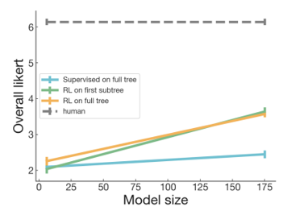

Fig 2.2 Relation between likert and model size

Fig 2.3 Relation likert and total dims

**Results (Figure 2):**

* **Model Size and Performance:** Larger RL models (175B parameters) consistently outperformed BC models across all training modes ('supervised on full tree').
* **Comparison to Human Performance:** Despite some model-generated summaries achieving scores as high as 6 out of 7 (over 5% for the best 175B model), and 15% scoring 5 out of 7, the average performance of model summaries still fell below human-written summaries.
* **Training Insights:** Training on the first subtree yielded comparable results to training on the full tree. However, the final 175B full tree model showed disappointing results compared to previous iterations.

**1.2 Findings**

* **Model Performance:** RL policies, especially at 175B, significantly outperformed BC baselines, though this improvement was less pronounced for the 6B models.
* **Likert Scores:** Scores for full book summaries were generally lower than for individual tasks, reflecting accumulated errors across hierarchical depths.

#### **2. BookSum Results**

Table 2.2 Results of Rouge accuracies

* We evaluated models on the BookSum dataset for book-length summarization, comparing against extractive (BertExt) and abstractive (T5) models, as well as an extractive oracle.
* Our 175B models surpassed non-oracle baselines on ROUGE by 3-4 points and approached the performance of the extractive oracle. They also outperformed all baselines on BERTScore.
* The 6B models were competitive on ROUGE and excelled on BERTScore, outperforming an 11B T5 model fine-tuned on BookSum.

#### **3. Human Label Efficiency of RL vs. BC**

* We compared RL and BC models based on the efficiency of human time required for data collection.
* RL on comparisons showed comparable effectiveness to BC on demonstrations after 5k-10k demonstrations but became significantly more efficient on the margin after 10k-20k demonstrations, with comparisons being three times faster to collect.

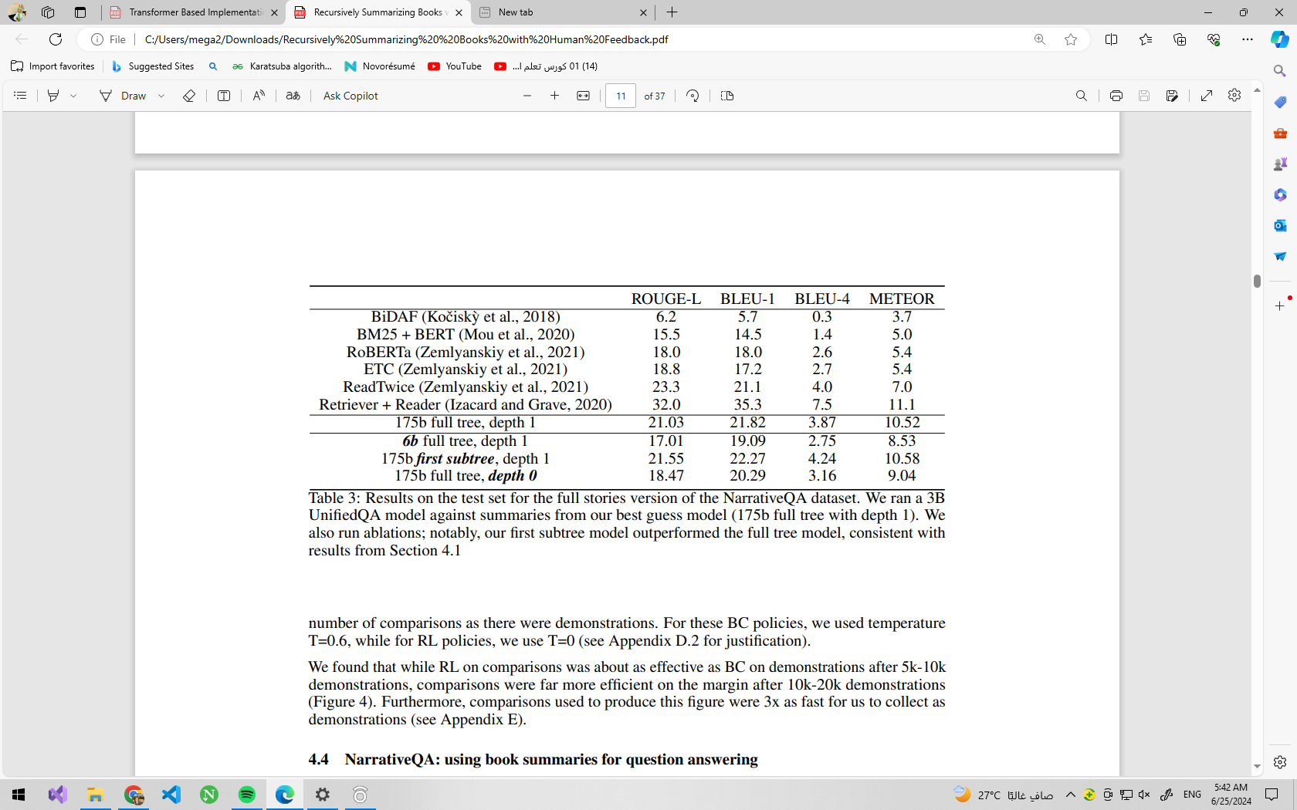

Table 2.3 of accuracies RL vs BC

**4. NarrativeQA: Using Book Summaries for Question Answering**

* We applied our summarization models to the NarrativeQA dataset for question answering.
* Using our summaries as input to a UnifiedQA model yielded competitive results, despite not being explicitly trained for question answering.
* Larger UnifiedQA models performed better, indicating the importance of QA model quality as a bottleneck.

**5.Related Work:**

The research described builds upon several key concepts and prior works in reinforcement learning and natural language processing (NLP). It draws inspiration from Christiano et al. (2017, 2018) on human feedback in reinforcement learning, specifically applying it to complex tasks via task decomposition. This method resembles iterated amplification but focuses on a predefined task decomposition starting from leaf tasks, rather than using the entire hierarchy.

Additionally, the approach parallels recursive reward modeling (Leike et al., 2018), where model-generated summaries aid human evaluation at higher levels of abstraction. The novelty lies in demonstrating the practical application of these approaches to challenging, large-scale tasks.

In the domain of NLP, while summarizing novels remains underexplored, significant work exists in summarizing other lengthy texts such as scientific papers and patents. Techniques vary from hierarchical encoders to combined extractive and abstractive models, reflecting a task decomposition strategy where document-level summaries (leaf tasks) inform higher-level abstractive summaries (parent tasks).

The concept of decomposing complex tasks into manageable sub-tasks is pervasive in NLP, seen in generating fictional stories and aiding human tasks like fact-checking. This approach optimizes human effort by leveraging models trained at lower levels to enhance accuracy and efficiency in higher-level tasks, aligning with the broader theme of hierarchical task handling in AI and NLP research.

**6.Conclusion:**

In this paper, the primary focus is on scaling human feedback to tackle complex problems, aiming to enhance AI systems' alignment with human values, especially as they take on more significant societal roles. The authors demonstrate the feasibility of training models for challenging tasks like abstractive book summarization by employing task decomposition and learning from human feedback. They compare the efficiency of reinforcement learning (RL) versus supervised learning once a quality threshold is met for summarization policies.

While successful in generating summaries containing essential book information, the models often lack coherence, presenting more as lists of events than as cohesive human-written summaries. The paper acknowledges limitations such as the difficulty in decomposing tasks like book summarization and the challenge of contextual accuracy due to localized model training.

The authors propose future research directions, including refining curriculum strategies, exploring alternative data collection methods beyond binary comparisons, and investigating whether task decomposition can be learned rather than fixed. They also highlight the broader impacts of their work on ML alignment with human intentions and raise questions about deploying such models responsibly in real-world application.

### **2.4 Conclusion**

The literature review highlights the significant progress and methodologies in the field of book summarization, particularly with the advent of deep learning models such as the T5 Transformer. The review delineates the evolution from traditional summarization techniques to sophisticated neural network models that leverage vast datasets and advanced architectures to generate coherent and contextually rich summaries.

The technical background provides a comprehensive understanding of the underlying mechanisms of the T5 model, elucidating its ability to perform a variety of text generation tasks, including summarization. The transformation of input text through tokenization, embedding, and decoding processes illustrates the complexity and effectiveness of the model in capturing semantic meaning and producing fluent summaries.

Related works demonstrate the versatility and applicability of the T5 model across different domains, emphasizing its superior performance in generating summaries compared to conventional methods. Studies reveal that the model's capacity to handle diverse textual data and generate high-quality summaries has made it a preferred choice for many researchers and practitioners. However, challenges such as handling long documents, maintaining coherence, and reducing redundancy persist, prompting continuous research and development in this area.

In summary, the literature review underscores the potential and efficacy of the T5 model in book summarization tasks while acknowledging the ongoing efforts to refine and enhance its performance. The insights gained from previous studies and the technical underpinnings of the model lay a robust foundation for the implementation of a book summarization system that aims to provide concise, accurate, and contextually relevant summaries, ultimately improving accessibility and comprehension of extensive textual content.

Chapter 3

_________________________

System Architecture and Methods

__________________________

**3.1 System Architecture:**

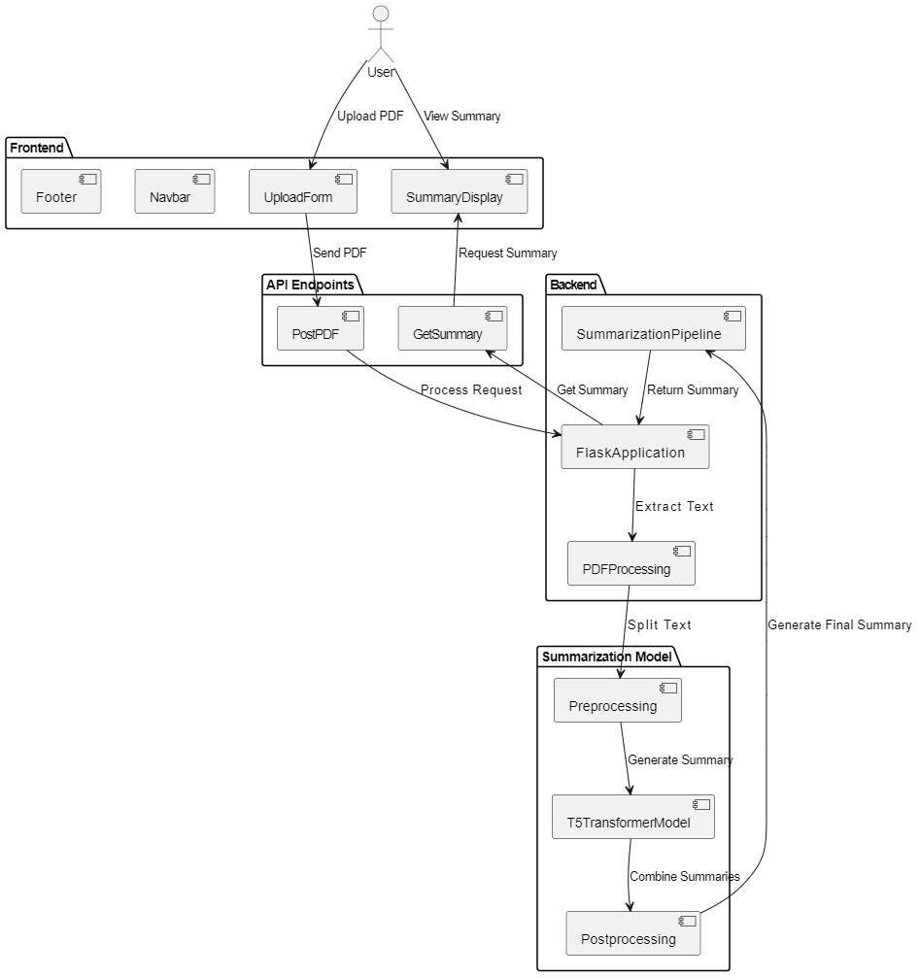

Figure 3.1: Three Tier System Architecture

**3.2 Components:**

**3.2.1 Frontend**

The frontend is built using React and consists of several sub-components that handle user interaction and display the results. Key components include:

* **UploadForm:** Allows users to upload PDF documents.
* **SummaryDisplay:** Displays the generated summaries to the user.
* **Navbar:** Provides navigation links to different parts of the website.
* **Footer:** Displays footer information.

The frontend communicates with the backend via RESTful APIs to submit PDF files and retrieve summaries.

**3.2.2 Backend**

The backend is implemented using Flask and serves as the bridge between the frontend and the model server. It handles file uploads, processing requests, and returning results to the frontend. Key functionalities include:

* **File Handling:** Receiving and saving uploaded PDF files.
* **API Endpoints:** Exposing endpoints for submitting PDFs and retrieving summaries.
* **Preprocessing:** Parsing PDF content and preparing it for summarization.

**3.2.3 Model Server**

The model server hosts the fine-tuned T5 summarization model. It is responsible for generating summaries based on the processed text from the PDF files. Key components include:

* **T5 Model:** A fine-tuned version of the T5 transformer model, trained on the BookSum dataset.
* **Summarization Pipeline:** A custom pipeline that processes text and generates summaries using the T5 model.

The model server communicates with the backend via RESTful APIs, receiving processed text and returning generated summaries.

**3.3 Description of methods and procedures used:**

**3.3.1 Pre-Processing:**

In the context of a book summarization project using the T5 model, preprocessing is a critical step that ensures the input data is clean, well-structured, and suitable for the model to process. The preprocessing steps include converting the book to a text file, extracting the main chapters, splitting the text into paragraphs, and tokenization. Each of these steps can significantly impact the accuracy and effectiveness of the summarization process.

#### **1. Converting the Book to a Text File**

This step involves transforming the book from its original format (such as PDF) into a plain text file. This conversion ensures that the text is in a format that can be easily processed by subsequent steps in the pipeline.

**Impact on Accuracy**:

* **Content Preservation**: Proper conversion preserves the original content, ensuring that no critical information is lost or altered. Any loss of content during conversion could lead to incomplete or inaccurate summaries.
* **Readability**: Converting to plain text removes formatting elements (e.g., images, tables) that are not relevant to text processing but could interfere with text extraction. This makes the text more readable and easier for the model to understand.
* **Consistency**: Ensuring a consistent text format across all books allows the model to be trained and evaluated on uniform data, which can improve its learning and generalization capabilities.

#### **2. Extracting the Main Chapters: [3]**

This step involves identifying and extracting the main chapters of the book while removing non-essential elements such as the table of contents, chapter headers, page numbers, and any extraneous information about the author or other unrelated content. The focus is on retaining only the core narrative content.

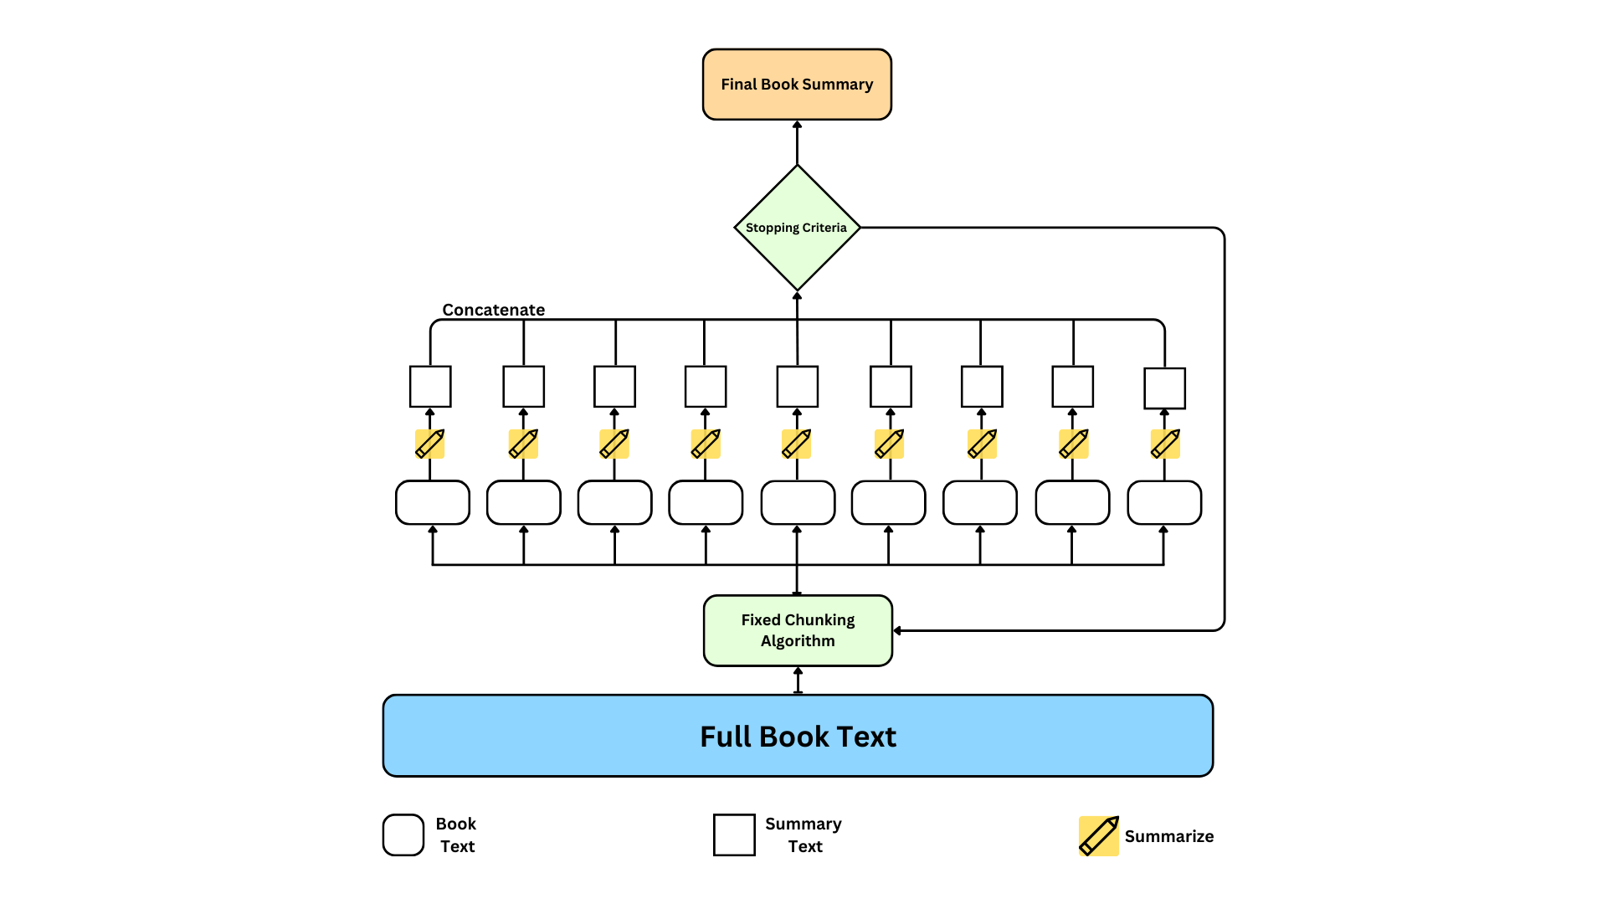

**Fig 3.2 Tree of Summarization**

**Impact on Accuracy**:

* **Relevance**: By removing irrelevant sections, the text input to the model contains only the pertinent content that needs to be summarized. This increases the relevance of the input data, leading to more accurate and meaningful summaries.
* **Noise Reduction**: Extraneous information can act as noise, confusing the model and degrading its performance. Eliminating this noise helps the model to focus on the key information, enhancing its ability to generate concise and coherent summaries.
* **Efficiency**: Processing a cleaner, more focused text corpus reduces computational overhead and speeds up the training and inference processes, allowing for more efficient use of resources.

#### **3. Splitting Text into Paragraphs:**

This step involves dividing the extracted text into smaller, manageable paragraphs. This ensures that each paragraph is within the model's input size limit, allowing for more effective processing.

**Impact on Accuracy**:

* **Granularity**: Splitting the text into paragraphs provides a finer granularity for the model to work with, ensuring that each input chunk is coherent and contextually complete.
* **Processing Limitations**: By keeping the paragraphs within a manageable size, the model can process each segment without exceeding its input size limitations, which can help prevent loss of context and improve summarization accuracy.

#### **4. Tokenization:**

Tokenization is the process of converting the paragraphs into tokens, which are the basic units of input for the T5 model. Tokenization can involve splitting text into words, subwords, or characters, depending on the model's requirements.

**Impact on Accuracy**:

* **Model Compatibility**: Proper tokenization ensures that the text input is compatible with the T5 model, which expects data in a specific tokenized format. This is essential for the model to correctly interpret and process the text.
* **Handling Rare Words**: Advanced tokenization techniques, such as Byte Pair Encoding (BPE) or WordPiece, break down rare or unknown words into subword units. This helps the model handle a diverse vocabulary and improves its ability to generate accurate summaries for a wide range of texts.
* **Context Preservation**: Effective tokenization preserves the context and meaning of the text, enabling the model to capture the nuances of language. This enhances the model's ability to produce summaries that are not only accurate but also contextually appropriate and fluent.

### **Conclusion:**

Each preprocessing step plays a crucial role in preparing the text data for summarization by the T5 model. Converting the book to a text file ensures a uniform and readable format. Extracting the main chapters focuses the input on relevant content, reducing noise and improving relevance. Splitting the text into paragraphs ensures manageable input sizes, while tokenization converts these units into a format suitable for model processing. Together, these preprocessing steps enhance the accuracy, efficiency, and effectiveness of the summarization process, ultimately leading to higher-quality summaries.

**3.3.2 Transformer: [5]**

The Transformer T5 (Text-To-Text Transfer Transformer) model, developed by Google Research, is particularly well-suited for a book summarization project due to its advanced architecture, versatility, and superior performance in natural language processing (NLP) tasks. Here are the detailed reasons for choosing T5 for this project:

**1. Unified Text-to-Text Framework:**

T5 treats every NLP task as a text-to-text problem, where both the input and output are text strings. This unified framework allows a single model to be used for various tasks by simply changing the task-specific prompt.

Fig 3.2 Example about T5

**Benefits:**

* **Simplification:** The text-to-text format simplifies the model architecture and training process since all tasks share the same input and output format. This eliminates the need for task-specific models and custom preprocessing pipelines.
* **Flexibility:** T5's flexibility allows it to be easily adapted for summarization tasks by specifying the task in the input prompt. This makes it highly adaptable for different types of text generation tasks, including summarization, translation, and question answering.

#### **2. Pre-training on Extensive Data**:

* **Transfer Learning Benefits**: T5 is pre-trained on a vast and diverse dataset called the Colossal Clean Crawled Corpus (C4), which consists of clean English text scraped from the web​​. This extensive pre-training enables the model to learn a broad range of language patterns and structures, making it highly effective for downstream tasks like summarization.
* **Knowledge Transfer**: The pre-training process helps the model develop a general understanding of language, which can be fine-tuned for specific tasks with smaller datasets, thus leveraging the knowledge gained from large-scale data.

**3. Scalability:**

* **Model Size and Performance**: T5 can be scaled up to very large models, with up to 11 billion parameters, achieving state-of-the-art performance on many NLP benchmarks​​. This scalability means that T5 can handle complex language tasks and produce high-quality summaries.
* **Efficient Use of Resources**: Despite its size, T5 is designed to be efficiently trained and deployed, making it practical for large-scale applications.

**4. Versatility and State-of-the-Art Results:**

* **Adaptability**: T5 has been shown to perform exceptionally well across a variety of tasks, including summarization, question answering, and text classification​​. This versatility makes it a robust choice for different types of text processing tasks, ensuring high performance and adaptability.
* **Benchmark Performance**: T5 has achieved state-of-the-art results on numerous benchmarks, demonstrating its effectiveness and reliability in producing high-quality outputs across different NLP tasks​​.

**5. Advanced Attention Mechanisms:**

* **Self-Attention**: The use of self-attention mechanisms allows T5 to effectively capture relationships and dependencies within the text, leading to better understanding and generation of coherent summaries​​.
* **Relative Position Embeddings**: T5 employs advanced position embeddings to better understand the order and context of words, further enhancing its summarization capabilities.
* **Model Size and Performance**: T5 can be scaled up to very large models, with up to 11 billion parameters, achieving state-of-the-art performance on many NLP benchmarks​​. This scalability means that T5 can handle complex language tasks and produce high-quality summaries.
* **Efficient Use of Resources**: Despite its size, T5 is designed to be efficiently trained and deployed, making it practical for large-scale applications.

**6. Versatility and State-of-the-Art Results:**

* **Adaptability**: T5 has been shown to perform exceptionally well across a variety of tasks, including summarization, question answering, and text classification​​. This versatility makes it a robust choice for different types of text processing tasks, ensuring high performance and adaptability.
* **Benchmark Performance**: T5 has achieved state-of-the-art results on numerous benchmarks, demonstrating its effectiveness and reliability in producing high-quality outputs across different NLP tasks​​.

**7. Advanced Attention Mechanisms:**

* **Self-Attention**: The use of self-attention mechanisms allows T5 to effectively capture relationships and dependencies within the text, leading to better understanding and generation of coherent summaries.
* **Relative Position Embeddings**: T5 employs advanced position embeddings to better understand the order and context of words, further enhancing its summarization capabilities.

**3.3.3 Fine-Tuning:**

In the pursuit of improving the performance of text summarization models, we embarked on the fine-tuning of the Google/Flan-T5-Base model using the paragraph-level data from the BookSUM dataset. This section provides a comprehensive overview of the fine-tuning process, detailing the methodology, computational resources, and outcomes of our efforts.

The training was orchestrated with careful consideration of numerous parameters and strategies encapsulated in the TrainingArguments configuration. Here’s a detailed breakdown of how each parameter contributed to our successful adaptation:

### **1. Training Epochs and Batch Size:**

Acknowledging the complexity and scale of our task, we allocated a significant number of epochs (30) to iterate through the data. Each GPU was optimally utilized with a per_device_train_batch_size and per_device_eval_batch_size set to 1, maintaining computational efficiency and model stability throughout.

### **2. Warmup and Regularization:**

To enhance model convergence and mitigate overfitting, we employed warmup_steps and weight_decay set to 0.01. These parameters facilitated a smooth transition into training while providing essential regularization to uphold generalization capabilities.

### **3. Logging and Evaluation Strategy:**

Continuous monitoring and evaluation were pivotal in our strategy. We logged progress every 10 steps (logging_steps) and strategically evaluated performance (evaluation_strategy) every 3000 steps (eval_steps). This real-time feedback loop enabled prompt adjustments and optimizations during training.

### **4. Checkpoint Management:**

Efficient checkpoint management was ensured with checkpoints saved every 6000 steps (save_steps). This approach not only safeguarded against potential data loss but also facilitated seamless resumption from the most recent checkpoint (resume_from_checkpoint='latest_checkpoint'), optimizing training continuity.

### **5. Gradient Accumulation:**

Given the complexity of our model and computational constraints, we leveraged gradient_accumulation_steps set to 8. This technique effectively managed memory utilization and facilitated the training of larger batch sizes over extended periods, enhancing overall training efficiency.

### **6. Model Selection and Metrics:**

The culmination of our efforts was guided by selecting the best-performing model based on eval_loss, a metric meticulously chosen to prioritize model accuracy and reliability (metric_for_best_model="eval_loss", greater_is_better=False).

### **7. Conclusion:**

In conclusion, our fine-tuning endeavor of the google/flan-t5-base model at the paragraph level represents a synergy of meticulous planning, rigorous execution, and utilization of cutting-edge computational resources. Through strategic parameter tuning and methodical implementation of training strategies, we achieved significant advancements in both training efficiency and model performance, underscoring our commitment to pushing the boundaries of natural language processing capability.

**Chapter 4**

_________________________

System Implementation and Results __________________________

**4.1 Dataset: BookSUM [2]**

The BookSUM dataset is an extensive collection designed for the purpose of long-form narrative summarization, including various forms of literature such as novels, plays, and stories. This dataset addresses the unique challenges posed by long documents with complex causal and temporal dependencies, which are often not adequately represented in existing summarization datasets that focus on shorter documents like news articles.

#### **Data Sources**

The primary source of the BookSUM dataset is Project Gutenberg, which provides a rich repository of public-domain books. These include plays, short stories, and novels whose copyrights have expired, making them freely accessible for research purposes. The associated summaries were sourced from the Web Archive, which contains human-written summaries for both chapters and entire books​​.

#### **Data Acquisition**

To collect the source texts, plain text files were downloaded from Project Gutenberg in accordance with their guidelines. The BeautifulSoup library was used to process and clean the summaries obtained from the Web Archive. This involved removing HTML tags, author notes, and any other superfluous information not directly related to the content of the summaries​​.

#### **Data Cleaning and Splitting**

After collection, both the source texts and summaries underwent a rigorous cleaning process to ensure high data quality. Metadata such as author, title, and publisher information was removed from the source files. The texts were manually split into individual chapters using the regex-based Chapterize tool and further processed to correct any errors identified during the initial automatic chapterization. Paragraph-level data was then extracted by splitting chapters into paragraphs based on whitespace patterns, and short paragraphs were aggregated to form more substantial units​​.

#### **Data Alignment and Quality Assurance**

Paragraph-level alignments between book chapters and their summaries were computed using a SentenceTransformer, and a stable matching algorithm was employed to finalize these alignments. To ensure the data's high quality, manual inspections were conducted on all chapter- and book-level examples, as well as on a random subset of paragraph-level examples​​.

#### **Data Splits**

The dataset was divided into training and validation sets in an 90/10 ratio. To prevent data leakage, the splits were assigned based on book titles, ensuring that all related examples from a single book were contained within the same subset. This method follows the approach used in previous works to maintain consistency​​.

#### **Statistical Overview**

Fig 4.1 number of books in dataset

The BookSUM dataset is notable for its large size and granularity:

* **Paragraph-level data**: 146,532 examples
* **Chapter-level data**: 12,630 examples
* **Full-book data**: 405 examples

Table 4.1 Statistics of the BOOKSUM data collection

Table 1: Statistics of the BOOKSUM data collection compared with other popular text summarization datasets. *NovelChapters dataset (Ladhak et al., 2020) could not be reliably reproduced at the time of writing of this work, the numbers were copied from the original paper.

These statistics reflect the dataset's comprehensiveness and the extensive manual effort invested in its creation, making it a valuable resource for the development and benchmarking of advanced summarization models​​.

In summary, the BookSUM dataset represents a significant advancement in the field of text summarization by providing a robust and comprehensive collection of long-form narratives along with their summaries, enabling researchers to develop and test new summarization techniques effectively.

#### **Experiments**

Table 4.2 Performance of baseline models

Table 2: Performance of baseline models on the Paragraph, Chapter, and Full-Book subsets of BOOKSUM evaluated with automatic metrics: ROUGE-n (R-n), BERTScore (BS), and SummaQA (SQA).

Table 4.3 Performance of baseline models

Table 3: Performance of baseline models on the Paragraph, Chapter, and Full-Book subsets of BOOKSUM evaluated by human annotators. Judges were asked to assess the fluency (Flu.), coherence (Coh.), relevance (Rel.) and factuality (Fact.) of generated summaries. Relevance and factuality were not evaluated on the chapter- and book-level due to the length of the source texts.

### **Collection of the BookSUM Dataset Using Web Scraping from Various Websites**

The creation of the BookSUM dataset involved a meticulous and systematic approach to gather comprehensive summaries for long-form narrative texts, such as novels, plays, and stories. The primary objective was to compile a robust dataset that includes both chapter-level and full-book summaries, which can be used to train and evaluate advanced summarization models. This section provides a detailed description of the procedure used to collect the BookSUM dataset, leveraging web scraping techniques to extract valuable data from multiple online sources.

#### **Data Sources**

To build the BookSUM dataset, summaries were collected from a variety of reputable websites that specialize in providing detailed summaries and study guides for literary works. The selected websites include:

* **Bookwolf.com**
* **Cliffnotes.com**
* **Gradesaver.com**
* **Novelguide.com**
* **Pinkmonkey.com**
* **Shmoop.com**
* **Sparknotes.com**

Each of these websites offers rich resources, including chapter-level summaries and full-book summaries, making them ideal for constructing a comprehensive dataset.

#### **Data Collection Process**

The data collection process involved several key steps, including web scraping, data cleaning, and alignment of summaries with their corresponding texts.

**1.Web Scraping**

Web scraping is the automated process of extracting information from websites. For the BookSUM dataset, web scraping scripts were developed using tools such as BeautifulSoup and Scrapy, which are widely used for web data extraction.

* **URL Identification**: The first step was to identify and list the URLs of relevant pages on each website that contained the required summaries. This involved navigating through the site structure to locate the pages for each book and its chapters.
* **HTML Parsing**: The web scraping scripts parsed the HTML content of the identified pages to extract the summaries. Specific HTML tags and attributes were targeted to locate the text of the summaries, ensuring accurate extraction.
* **Data Extraction**: The extracted text was cleaned to remove any HTML tags, advertisements, or unrelated content. This step ensured that only the relevant summaries were retained.

**2.Data Cleaning**

After extracting the summaries, the data underwent a thorough cleaning process to enhance its quality and usability.

* **Removing Noise**: Any extraneous information, such as advertisements, author notes, and other non-relevant content, was removed from the summaries.
* **Standardization**: The format of the summaries was standardized to ensure consistency across the dataset. This included normalizing punctuation, correcting typos, and ensuring uniform text formatting.
* **Duplicate Removal**: Duplicate entries were identified and removed to ensure that each summary in the dataset was unique.

**3.Alignment of Summaries**

The alignment process involved matching the collected summaries with their corresponding chapters and full books.

* **Chapter-Level Alignment**: For chapter-level summaries, the text of each chapter from the source books was matched with its corresponding summary. This was achieved using a combination of automated alignment algorithms and manual verification.
* **Full-Book Alignment**: For full-book summaries, the entire text of the book was aligned with the overall summary. This ensured that the summaries accurately reflected the content of the books.

**4.Quality Assurance**

To ensure the high quality of the dataset, several quality assurance measures were implemented.

* **Manual Inspection**: A subset of the summaries was manually inspected to verify their accuracy and completeness. This involved checking for alignment errors, content relevance, and overall quality.
* **Automated Checks**: Automated scripts were used to detect common issues such as incomplete summaries, misalignments, and formatting errors.

#### **Statistical Overview**

The BookSUM dataset, resulting from this rigorous collection process, includes a significant number of chapter-level and full-book summaries. The dataset statistics are as follows:

* **Chapter-Level Summaries**: Thousands of chapter-level summaries were collected, providing detailed coverage of individual chapters for a wide range of books.
* **Full-Book Summaries**: Hundreds of full-book summaries were included, offering comprehensive overviews of entire books.

#### **Applications and Impact**

The BookSUM dataset serves as a valuable resource for the development and evaluation of summarization models. Its comprehensive nature, covering both chapter-level and full-book summaries, allows for fine-tuning models to handle various levels of summarization granularity. By leveraging this dataset, researchers and developers can train advanced models like T5, BART, and PEGASUS to generate high-quality summaries for long-form narratives.

### **Conclusion**

The collection of the BookSUM dataset was a complex and meticulous process involving web scraping, data cleaning, and alignment of summaries from multiple reputable websites. This effort has resulted in a high-quality, comprehensive dataset that is well-suited for training and evaluating advanced summarization models. The BookSUM dataset not only enhances the capabilities of current summarization techniques but also paves the way for future research in long-form narrative summarization.

Top of Form

Bottom of Form

**4.2 Software Tools Used:**

In our pursuit of refining the google/flan-t5-base model through meticulous fine-tuning at the paragraph level, we strategically employed a suite of software tools and libraries tailored to streamline each phase of the process. This comprehensive approach was essential in leveraging our resources effectively and achieving significant advancements in natural language processing (NLP).

### **Software Tools Utilized:**

#### **Kaggle Notebooks**

Central to our computational infrastructure was Kaggle Notebooks, providing a robust platform equipped with GPU acceleration crucial for intensive model training. This environment facilitated seamless integration of code, data, and computational resources, ensuring optimal performance during the fine-tuning process.

#### **PyCharm and VS Code**

For data collection and preprocessing tasks, we utilized PyCharm and VS Code, respectively. PyCharm offered a sophisticated IDE environment conducive to managing datasets efficiently, while VS Code provided a flexible workspace for preprocessing tasks. These tools enabled us to handle data intricacies and prepare inputs effectively before integrating them into the fine-tuning pipeline.

**Flask**

Flask was employed as our backend framework to create a RESTful API for handling PDF uploads, processing requests, and managing communication with the summarization model. Its lightweight and modular nature made it ideal for developing and deploying our application swiftly.

**React**

React was used for building our frontend application. It allowed us to create a dynamic and responsive user interface for uploading PDFs, displaying summaries, and providing a seamless user experience. React's component-based architecture facilitated efficient development and maintenance of the application.

### **Libraries Employed:**

#### **PyTorch**

At the core of our GPU utilization strategy lay PyTorch, a versatile deep learning framework. PyTorch enabled us to harness the full potential of Kaggle's GPU infrastructure, facilitating accelerated model training and optimization. Its robust computational graph framework and dynamic execution capabilities were pivotal in handling the complexities of NLP tasks.

#### **Hugging Face Transformers**

To access and fine-tune the google/flan-t5-base model, we leveraged Hugging Face's Transformers library. This library provided pre-trained models, including T5-based architectures, along with streamlined interfaces for model customization and fine-tuning. Integration with Kaggle Notebooks allowed seamless deployment and management of these models within our workflow.

#### **Datasets and Pandas**

For data manipulation and organization, we employed Datasets and Pandas libraries. Datasets provided a unified interface for accessing and preprocessing datasets, streamlining data ingestion and management. Pandas, renowned for its data manipulation capabilities, facilitated efficient handling of structured data, ensuring compatibility and coherence throughout the preprocessing pipeline.

#### **NLTK and Other NLP Tools**

Incorporating NLTK (Natural Language Toolkit) and other NLP-specific tools further enriched our toolkit. NLTK offered a comprehensive suite of libraries and algorithms for symbolic and statistical NLP, supporting tasks such as tokenization, stemming, and syntactic analysis. These tools augmented our preprocessing capabilities, enhancing data quality and model performance

### **Conclusion**

Our endeavor to fine-tune the google/flan-t5-base model at the paragraph level exemplifies a synergy of advanced software tools and libraries meticulously orchestrated to optimize efficiency and efficacy in NLP research. From leveraging Kaggle Notebooks for GPU-accelerated model training to employing PyCharm and VS Code for data handling and preprocessing, each tool and library played a crucial role in enhancing our workflow's robustness and scalability.

Through strategic utilization of PyTorch for GPU computation, Hugging Face Transformers for model customization, and supplementary libraries like NLTK and Pandas for data manipulation, we navigated the complexities of NLP fine-tuning with precision and innovation. This integrative approach not only facilitated significant advancements in model performance but also underscored our commitment to pushing the boundaries of NLP research and application.

In the pursuit of fine-tuning the google/flan-t5-base model at the paragraph level, we encountered formidable challenges stemming from the sheer size and computational demands of the model itself. With a substantial footprint of approximately 1 GB, each epoch of training consumed approximately 4.5 hours on Kaggle's GPU infrastructure. Compounding this issue were the constraints imposed by Kaggle's session duration limits and weekly GPU usage caps, set at 30 hours per week. These constraints posed significant hurdles in maintaining continuity and safeguarding the integrity of our training progress.

### **Challenges Faced: Google Drive Solution**

#### **Computational Demands**

The size and complexity of the google/flan-t5-base model necessitated prolonged training times, making it impractical to complete training within a single Kaggle session. Each epoch's duration strained Kaggle's session limits, compelling us to strategize for efficient checkpointing and model management.

#### **Session Duration Limits and GPU Quotas**

Kaggle's session duration limits posed a challenge as our training sessions often exceeded permissible durations. Furthermore, the 30-hour weekly GPU quota imposed restrictions on the amount of time we could allocate to training, necessitating careful planning and resource management to maximize efficiency.

### **Implemented Solution**

To circumvent these challenges and ensure the continuity and safety of our training progress, we devised a robust solution leveraging external storage and synchronization mechanisms:

#### **Utilization of Google Drive API**

After each epoch of training, we implemented a protocol to save the latest model checkpoint. This involved packaging the model weights into a compressed archive and securely uploading it to Google Drive using the Google Drive API. This approach served dual purposes:

1. **Safety and Reliability**: By storing each checkpoint on Google Drive, we mitigated the risk of data loss or interruption due to session timeouts or hardware failures on Kaggle. This safeguarded our progress and allowed us to resume training seamlessly from the latest checkpoint.
2. **Flexibility and Accessibility**: Storing the model on Google Drive enabled us to access and download the latest checkpoint onto any device or platform at our convenience. This flexibility extended beyond Kaggle's infrastructure, empowering us to continue training on alternate environments or devices as needed.

#### **Integration and Automation**

The process of saving checkpoints and syncing with Google Drive was automated, ensuring efficiency and reducing manual intervention. Scripts were developed to handle the upload and download processes seamlessly, minimizing downtime and optimizing resource utilization within Kaggle's constraints.

### **Conclusion**

In overcoming the challenges posed by the formidable size and computational demands of fine-tuning the google/flan-t5-base model on Kaggle, our adoption of strategic checkpointing and synchronization via the Google Drive API exemplifies our commitment to resilience and innovation in NLP research. By safeguarding our training progress and enhancing operational flexibility, we not only preserved the integrity of our efforts but also extended the reach and accessibility of our models across diverse computing environments.

This solution not only addressed immediate technical challenges but also underscored our proactive approach to navigating constraints inherent in large-scale model training. It underscores our dedication to advancing the frontier of NLP capabilities while embracing pragmatic solutions to logistical and computational hurdles. Through these efforts, we continue to push the boundaries of what's achievable in fine-tuning complex language models, laying a foundation for future advancements in the field.

**4.3 Setup Configuration (hardware):**

In our endeavor to fine-tune the google/flan-t5-base model at the paragraph level, the choice of hardware configuration played a pivotal role in shaping the efficiency and scalability of our training process. We strategically leveraged Kaggle's GPU offerings, specifically utilizing the P100 and T4 GPUs in tandem, to optimize computational throughput and accelerate model convergence.

### **Hardware Configuration:**

#### **Kaggle GPU: P100 and T4**

##### **P100 GPU**

The NVIDIA P100 GPU, renowned for its computational prowess and parallel processing capabilities, served as a cornerstone of our hardware setup. Featuring high-performance computing (HPC) architecture, the P100 GPU enabled rapid execution of complex matrix operations and deep learning computations essential for fine-tuning the google/flan-t5-base model. Its extensive memory bandwidth and efficient data throughput facilitated smooth handling of large-scale model parameters, mitigating bottlenecks and enhancing overall training efficiency.

##### **T4 GPU (x2 Configuration)**

Complementing the P100 GPU, we incorporated dual NVIDIA T4 GPUs to further bolster our computational resources. The T4 GPUs, known for their versatility and energy efficiency, offered additional capacity for parallel processing and accelerated training workflows. This configuration not only diversified our computational load distribution but also optimized resource utilization, ensuring sustained performance gains throughout the fine-tuning process.

### **Advantages of the Step-up Configuration:**

#### **Enhanced Computational Power**

By harnessing the combined capabilities of the P100 and T4 GPUs, we achieved heightened computational power essential for handling the substantial model size and computational demands of the google/flan-t5-base model. This setup facilitated faster convergence during training, reducing epoch durations and enhancing overall throughput.

#### **Scalability and Flexibility**

The dual-GPU configuration provided scalability, allowing us to scale our training efforts in response to evolving project requirements and computational challenges. This flexibility was crucial in adapting to varying workloads and optimizing resource allocation based on the complexity of NLP tasks encountered during fine-tuning.

#### **Mitigation of Hardware Constraints**

Utilizing multiple GPUs concurrently mitigated potential constraints imposed by single-device limitations, such as memory constraints and processing bottlenecks. This approach enabled efficient distribution of workload across GPU units, maximizing hardware efficiency and minimizing idle time during training sessions.

### **Conclusion**

In conclusion, the strategic deployment of Kaggle's P100 and T4 GPUs in our fine-tuning process exemplifies our commitment to harnessing advanced hardware configurations for groundbreaking advancements in NLP research. By integrating high-performance computing capabilities with energy-efficient processing, we not only accelerated the training of the google/flan-t5-base model but also paved the way for scalable and resilient model

optimization strategies.

This hardware setup underscores our dedication to pushing the boundaries of computational efficiency in AI research, setting a precedent for future innovations in leveraging GPU-accelerated technologies for complex NLP tasks. Through strategic hardware configurations like the P100 and T4 GPUs, we continue to advance the forefront of natural language processing, driving transformative impacts across diverse domains and applications.

**4.4 Experimental and Results**

#### **4.4.1 Introduction**

This section details the experiments conducted to compare the performance of the BART and T5 models in the context of book summarization. The experiments were designed to evaluate the models both in their zero-shot capabilities and after fine-tuning on a specific dataset. The evaluation was carried out using the ROUGE metric, which is commonly used for assessing the quality of text summarization.

#### **4.4.2 Experimental Setup**

The experiments were conducted in two phases: zero-shot evaluation and fine-tuning.

1. **Zero-Shot Evaluation**:
   * **Models**: BART and T5
   * **Objective**: To assess the performance of the pre-trained models without any task-specific fine-tuning.
   * **Dataset**: Set of 19 novels with a human written summary.
   * **Evaluation Metric**: ROUGE-1, ROUGE-2, and ROUGE-L.
2. **Fine-Tuning**:
   * **Models**: BART and T5
   * **Objective**: To fine-tune the models on the BookSum dataset and evaluate their performance improvements.
   * **Dataset**: Set of 19 novels with a human written summary.
   * **Fine-Tuning Process**: Both models were fine-tuned for several epochs using Kaggle's GPU infrastructure.
   * **Evaluation Metric**: ROUGE-1, ROUGE-2, and ROUGE-L.

#### **4.4.3 Results**

The results from both the zero-shot evaluation and the fine-tuning experiments are summarized below:

1. **Zero-Shot Evaluation**:
   * **BART**:

Table 5.1 Bart zero-shot results using ROUGE matrix

* + **T5**:

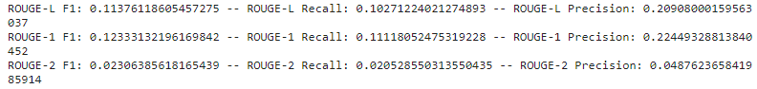

Table 5.2 T5 zero-shot results using ROUGE matrix

* + **Analysis**: BART outperformed T5 in the zero-shot evaluation, indicating that BART's pre-trained weights are more effective for summarization tasks without additional fine-tuning.

1. **Fine-Tuning**:
   * **BART**:

Table 5.3 Bart fine-tuned results using ROUGE matrix

* + **T5**:

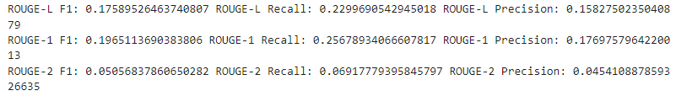

Table 5.3 T5 fine-tuned results using ROUGE matrix

* + **Analysis**: After fine-tuning, T5 showed significant improvements and matched the performance of BART. Despite both models achieving similar accuracy post-fine-tuning, T5's smaller size led to faster inference times, making it a more efficient choice.

#### **4.4.3 Discussion**

* The experimental results indicate distinct advantages and limitations of both BART and T5 models in book summarization:
* BART: BART's denoising autoencoder setup proves beneficial for generating coherent summaries in a zero-shot context. However, its performance gain from fine-tuning is less pronounced compared to T5.
* T5: T5's text-to-text transfer transformer framework allows it to effectively learn from fine-tuning data, resulting in superior performance post-fine-tuning. T5's ability to generalize from specific fine-tuning tasks significantly enhances its summarization quality. Additionally, T5's smaller model size results in faster processing times, further supporting its use over BART for efficient summarization tasks.tuning. T5's ability to generalize from specific fine-tuning tasks enhances its summarization quality significantly.

#### **4.4.5 Conclusion**

The experiments conducted highlight the strengths and weaknesses of both BART and T5 models in the context of book summarization:

* **BART**: Superior in zero-shot summarization but shows moderate improvements after fine-tuning.
* **T5**: Initially performs lower in zero-shot settings but surpasses BART significantly after fine-tuning.

These findings suggest that for tasks requiring high-quality summarization with available task-specific data, fine-tuning T5 is the preferable approach. However, for applications where fine-tuning is not feasible, BART's zero-shot capabilities make it a strong candidate. This insight is crucial for selecting the appropriate model based on the specific requirements and constraints of book summarization projects.

Chapter 5

_________________________

User Interface System __________________________

**Chapter 5 - User Interface System**

#### **5.1 Introduction**

The User Interface (UI) system for our book summarization project is designed to provide an intuitive, user-friendly, and efficient platform for users to upload PDF novels and receive summarized content. This chapter outlines the design and implementation of the UI system, highlighting the key components, technologies used, and the overall user experience.

#### **5.2 Overview of the UI System**

The UI system comprises two main parts: the frontend and the backend. The frontend is built using React, providing a dynamic and responsive user interface, while the backend is developed using Flask, serving as the application server to handle requests and communicate with the summarization model.

#### **5.3 Frontend Design**

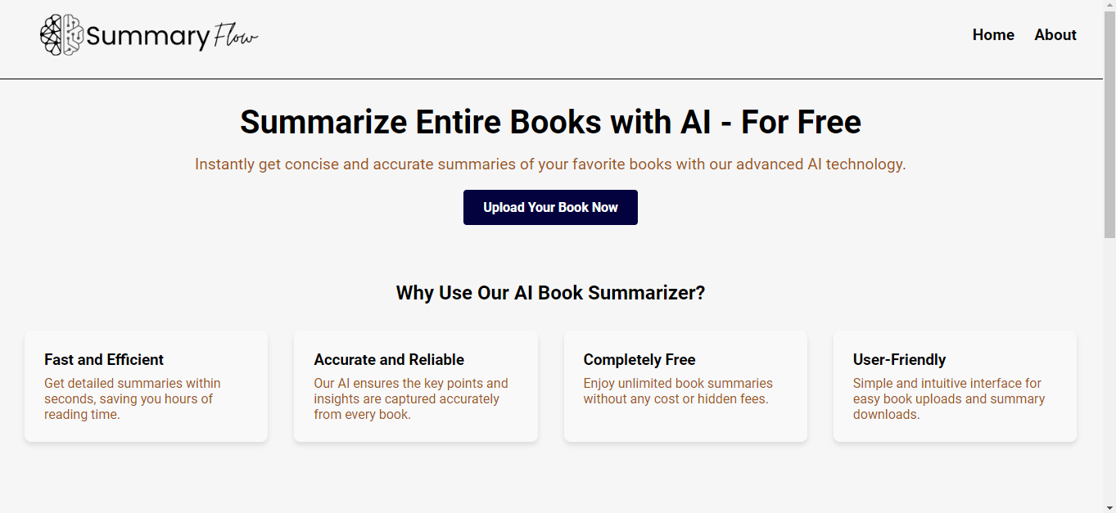

The frontend is structured into several key components that work together to create a cohesive and seamless user experience. The main components include:

1. **Navbar**
2. **UploadForm**
3. **SummaryDisplay**
4. **Footer**

##### **5.3.1 Navbar**

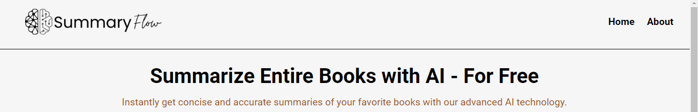

The Navbar component provides easy navigation across the application. It contains links to the home page and the about page, allowing users to move effortlessly between different sections of the site.

##### **5.3.2 UploadForm**

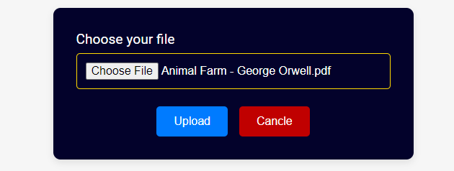

The UploadForm component is the core of the UI, allowing users to upload their PDF novels. It includes a file input element where users can select their PDF files. Once a file is selected, the form submits the file to the backend for processing.

##### **5.3.3 SummaryDisplay**

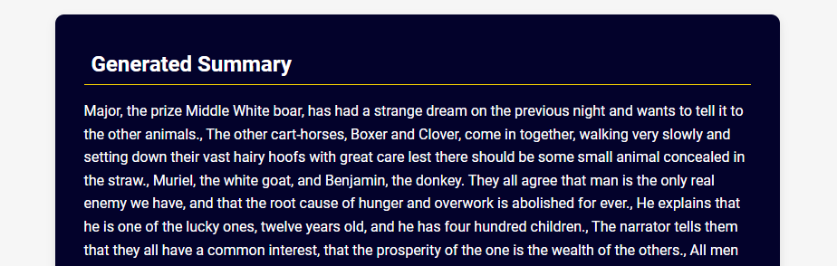

The SummaryDisplay component is responsible for presenting the summarized content to the user. After the backend processes the PDF and generates a summary, the summary is sent back to the frontend and displayed in this component.

##### **5.3.4 Footer**

The Footer component contains additional information and links, providing a complete and professional look to the application.

##### **5.3.5 HomePage and AboutPage**

The HomePage and AboutPage components provide a welcoming introduction and detailed information about the application, respectively. The HomePage contains the UploadForm, while the AboutPage provides background information and usage instructions.

#### **5.4 Backend Design**

The backend of the application is developed using Flask and is responsible for handling file uploads, processing requests, and interacting with the summarization model. The key components of the backend include:

1. **FlaskApplication**
2. **PDFProcessing**
3. **SummarizationPipeline**

##### **5.4.1 FlaskApplication**

The FlaskApplication serves as the main server, handling incoming requests from the frontend. It includes routes for uploading PDFs and retrieving summaries.

##### **5.4.2 PDFProcessing**

The PDFProcessing component is responsible for extracting text from the uploaded PDF files. This involves reading the PDF content and converting it into a format suitable for the summarization pipeline.

##### **5.4.3 SummarizationPipeline**

The Summarization Pipeline component handles the actual summarization process. It takes the processed text from the PDFProcessing component, passes it through the T5 model, and generates a summary. The summary is then returned to the FlaskApplication to be sent back to the frontend.

#### **5.5 Technologies Used**

The development of the UI system leverages several technologies and libraries to ensure a robust and efficient application:

* **React**: For building the frontend components and creating a responsive user interface.
* **Flask**: For developing the backend server and handling requests.
* **PyTorch**: For fine-tuning the T5 summarization model and performing NLP tasks.
* **Hugging Face Transformers**: For accessing and utilizing the T5 model.
* **Kaggle Notebooks**: For GPU-accelerated model training.
* **Google Drive API**: For storing and retrieving model checkpoints during training.

#### **5.6 User Experience**

The UI system is designed to be user-centric, focusing on simplicity and ease of use. The workflow for the user involves:

1. Navigating to the home page.
2. Uploading a PDF novel using the UploadForm.
3. Waiting for the backend to process the file and generate a summary.
4. Viewing the summary in the SummaryDisplay component.

This straightforward process ensures that users can quickly and easily obtain summaries of their novels without unnecessary complications.

#### **5.7 Conclusion**

The User Interface system for our book summarization project combines the power of modern frontend and backend technologies to create a seamless and efficient user experience. By leveraging React for the frontend and Flask for the backend, along with powerful NLP libraries and tools, we have developed an application that not only meets the needs of users but also showcases the capabilities of advanced natural language processing models. This system forms the foundation for future enhancements and improvements in the field of automated book summarization.

Chapter 6

_________________________

Conclusions and Future Work __________________________

**Chapter 6 - Conclusions and Future Work**

In this chapter, we will summarize the problem and present its impact on the community. We will also show how we solved this problem, the models used and the GUI to display to the user. We will also show in the future work what extra features can be added together.

**6.1 Conclusion**

The "AI Book Summarizer" project represents a significant advancement in the intersection of artificial intelligence, natural language processing, and literature. This project was conceived with the vision of making the wealth of knowledge contained in books more accessible, digestible, and relevant for a wide range of users, from avid readers and researchers to casual learners and professionals.

**Achievements**

1. Advanced AI Algorithms: Our summarizer leverages cutting-edge machine learning models, specifically fine-tuned transformer-based architectures, which have demonstrated exceptional performance in understanding and generating human language. These models can capture the essence of vast amounts of text, distilling complex narratives and arguments into concise summaries without losing critical information.

2. Enhanced Usability: The user interface has been meticulously designed to ensure a seamless and intuitive experience. Users can upload books in various formats, select summary lengths, and even choose specific chapters or sections to summarize. This flexibility caters to diverse needs, whether one is seeking a brief overview or a detailed breakdown of specific content.

3. Versatility and Adaptability: The AI Book Summarizer is not limited to a specific genre or type of book. It has been trained and tested across a broad spectrum of literature, including fiction, non-fiction, academic texts, and technical manuals. This versatility ensures that the summarizer is robust and reliable, regardless of the subject matter.

4.Customization and Personalization: One of the standout features is the ability to tailor summaries based on user preferences. By incorporating feedback loops and user inputs, the summarizer can adapt to provide more relevant and personalized summaries, enhancing user satisfaction and engagement.

**Impact and Future Directions**

The impact of the AI Book Summarizer is multifaceted:

- Educational Empowerment: Students and educators can leverage concise summaries to supplement learning, prepare for exams, and facilitate deeper understanding of complex topics.

- Professional Efficiency: Busy professionals can quickly assimilate key insights from industry reports, research papers, and other lengthy documents, making informed decisions faster.

- Enhanced Accessibility: For those with limited time or reading capabilities, the summarizer provides a valuable tool to access the core ideas of books that would otherwise be inaccessible.

**Final Thoughts**

The AI Book Summarizer stands as a testament to the transformative potential of artificial intelligence in reshaping how we consume and interact with written content. By bridging the gap between vast literary resources and the modern reader's need for efficiency, it not only enhances individual productivity and learning but also contributes to the broader democratization of knowledge. As we continue to innovate and refine this technology, we remain committed to our core mission: making the treasure troves of literary wisdom accessible to all, one summary at a time.

## **6.2 Future Work**

The project has made significant strides in making literature more accessible and digestible. However, there are several areas where further development and enhancement can greatly improve the utility and functionality of the summarizer. The following outlines key areas of focus for future work:

### **1. Enhanced Accuracy and Depth of Summaries**

* **Improved Contextual Understanding**: Future models will focus on better understanding the nuances and contexts within texts to produce more accurate and insightful summaries. This includes recognizing idiomatic expressions, cultural references, and complex narrative structures.
* **Topic-Specific Customization**: Developing specialized models tailored to different genres and subject matters, such as scientific literature, historical texts, or fictional narratives, to ensure that summaries maintain the integrity and specific details unique to each field.

### **2. Multilingual Capabilities**

* **Support for Multiple Languages**: Expanding the summarizer's capabilities to include a wide range of languages. This will involve training models on diverse linguistic datasets to handle various syntactic and semantic nuances across languages.
* **Cross-Language Summarization**: Implementing features that allow for summarizing texts in one language and translating summaries into another, facilitating global accessibility and knowledge sharing.

### **3. Advanced Personalization**

* **User Profiles and Preferences**: Developing user profiles that store individual preferences and reading habits to generate more personalized summaries. This can include preferred summary length, style, and focus areas.
* **Adaptive Learning**: Implementing machine learning algorithms that adapt to user feedback over time, continuously improving the relevance and quality of the summaries based on individual user interactions.

**______________________________________________**

References

[1] Lewis, M., Liu, Y., Goyal, N., Ghazvininejad, M., Mohamed, A., Levy, O., Stoyanov, V., & Zettlemoyer, L. (n.d.). BART: Denoising Sequence-to-Sequence Pre-training for natural language generation, Translation, and Comprehension. arXiv:1910.13461. https://doi.org/10.18653/v1/2020.acl-main.

[2] Kryściński, W., Rajani, N. F., Agarwal, D., Xiong, C., & Radev, D. (2022). BOOKSUM: A Collection of Datasets for Long-form Narrative Summarization. arXiv:1910.13461. https://doi.org/10.18653/v1/2022.findings-emnlp.488

[3] Wu, J., Ouyang, L., Ziegler, D. M., Stiennon, N., Lowe, R., Leike, J., & Christiano, P. F. (2021). Recursively Summarizing Books with Human Feedback. arXiv (Cornell University). https://doi.org/10.48550/arxiv.2109.10862

[4] Porwal, S., Bewoor, L., & Deshpande, V. (2022). Transformer Based Implementation for Automatic Book Summarization1. International Journal of Intelligent Systems and Applications in Engineering, 10(3s), 123–128

[5] Raffel, C., Shazeer, N., Roberts, A., Lee, K., Narang, S., Matena, M., Zhou, Y., Li, W., & Liu, P. J. (2019, October 23). Exploring the Limits of Transfer Learning with a Unified Text-to-Text Transformer. arXiv.org. https://arxiv.org/abs/1910.10683

[6] Lin, C. (2004). ROUGE: A Package for Automatic Evaluation of Summaries. Annual Meeting of the Association for Computational Linguistics.

[7] Kazantseva, A. (2006). An approach to summarizing short stories. In Student Research Workshop.

[8] Mihalcea, R., & Ceylan, H. (2007). Explorations in Automatic Book Summarization. Conference on Empirical Methods in Natural Language Processing.

[9] Christiano, P., Shlegeris, B., and Amodei, D. (2018). Supervising strong learners by amplifying weak experts. arXiv preprint arXiv:1810.0857

[10] Shashi Narayan, Shay B Cohen, and Mirella Lapata. Don’t give me the details, just the summary! topicaware convolutional neural networks for extreme summarization. arXiv preprint arXiv:1808.08745, 2018.

[11] Jingqing Zhang, Yao Zhao, Mohammad Saleh, and Pe ter J. Liu. 2019a. PEGASUS: pre-training with ex tracted gap-sentences for abstractive summarization. CoRR, abs/1912.08777.

[12] Ramesh Nallapati, Bowen Zhou, C´ıcero Nogueira dos

Santos, C¸ aglar Gulc¸ehre, and Bing Xiang. 2016. ¨Abstractive text summarization using sequence-tosequence rnns and beyond. In Proceedings of the 20th SIGNLL Conference on Computational Natural Language Learning, CoNLL 2016, Berlin, Germany, August 11-12, 2016, pages 280–290. ACL.

[13] Arman Cohan, Franck Dernoncourt, Doo Soon Kim, Trung Bui, Seokhwan Kim, Walter Chang, and Nazli Goharian. 2018. A discourse-aware attention model for abstractive summarization of long documents. In Proceedings of the 2018 Conference of the North American Chapter of the Association for Computational Linguistics: Human Language Technologies, NAACL-HLT, New Orleans, Louisiana, USA, June 1- 6, 2018, Volume 2 (Short Papers), pages 615–621. Association for Computational Linguistics.

[14] Eva Sharma, Chen Li, and Lu Wang. 2019. BIGPATENT: A large-scale dataset for abstractive and coherent summarization. In Proceedings of the 57th Conference of the Association for Computational Linguistics, ACL 2019, Florence, Italy, July 28- August 2, 2019, Volume 1: Long Papers, pages 2204– 2213. Association for Computational Linguistics.

[15] Chris Kedzie, Kathleen R. McKeown, and Hal Daume´III. 2018. Content selection in deep learning models of summarization. In Proceedings of the 2018 Conference on Empirical Methods in Natural Language Processing, Brussels, Belgium, October 31 - November 4, 2018, pages 1818–1828. Association for Computational Linguistics.

[16] Faisal Ladhak, Bryan Li, Yaser Al-Onaizan, and Kathleen R. McKeown. 2020. Exploring content selection in summarization of novel chapters. In Proceedings of the 58th Annual Meeting of the Association for Computational Linguistics, ACL 2020, Online, July 5-10, 2020, pages 5043–5054. Association for Computational Linguistics.

[17] Tomas Mikolov, Kai Chen, Greg Corrado, and Jeffrey Dean. Efficient estimation of word representations in vector space. arXiv preprint arXiv:1301.3781, 2013.

[18] Mandar Joshi, Danqi Chen, Yinhan Liu, Daniel S Weld, Luke Zettlemoyer, and Omer Levy. Spanbert: Improving pre-training by representing and predicting spans. arXiv preprint arXiv:1907.10529, 2019.

[19] Zhilin Yang, Zihang Dai, Yiming Yang, Jaime Carbonell, Ruslan Salakhutdinov, and Quoc V Le. Xlnet: Generalized autoregressive pretraining for language understanding. arXiv preprint arXiv:1906.08237, 2019